ETL – Tutorial to Use Talend to Move Data from OpenMRS to OMOP CDM

Dr. Barry Levine

1. Create the openmrs database 3

2. Set up pgAdmin 3

3. Create the PostgreSQL database 3

4. Download the ATHENA SNOMED VOCABULARY 5

5. Set up the Common-Data-Model/PostgreSQL database and populate the database with the Snomed Vocabulary 6

6. Set up Talend – create jobs to move data from source to target 20

The ETL scripts we used were based on the following document:

[https://wiki.openmrs.org/download/attachments/84476300/OpenMRS%20ETL.docx?version=1&modificationDate=1436743360000&api=v2](https://wiki.openmrs.org/download/attachments/84476300/OpenMRS%20ETL.docx?version=1&modificationDate=1436743360000&api=v2 )

The document was referenced by Paul Biondich in his post at:

<https://talk.openmrs.org/t/openmrs-and-ohdsi/24930>

The ***source*** is a mysql sample openmrs database included in the install of OpenMRS version 2.1.4. The ***target*** is a PostgreSQL database – we used PostgreSQL 13.

In this document we will describe the ETL process using Talend Open Studio for Data Integration version 7.3.1.

(<https://www.talend.com/home/>). Note, we used Mac computers for this process, although it should work well on a PC.

The final piece of software to set up is pgAdmin 4; other more recent versions of pgAdmin should work well.

***We are using Java JDK 8***

An overview of the steps to set up the ETL system are

1. Create the openmrs database
2. Set up pgAdmin
3. Create the PostgreSQL database
4. Download the ATHENA SNOMED VOCABULARY
5. Set up the Common-Data-Model/PostgreSQL database and populate the database with the Snomed Vocabulary
6. Set up Talend – create jobs to move data from source to target

The remainder of this document will consist of elaborations of each of the 6 steps, above.

# Create the openmrs database

Set up OpenMRS with a demo database.

# Set up pgAdmin

pgAdmin download can be found here: <https://www.pgadmin.org/>

# Create the PostgreSQL database

Choose an appropriate name for the target database. In the example provided herein we used *op1*

# Download the ATHENA SNOMED VOCABULARY

Download ATHENA SNOMED VOCABULARY from

<https://athena.ohdsi.org/vocabulary/list>

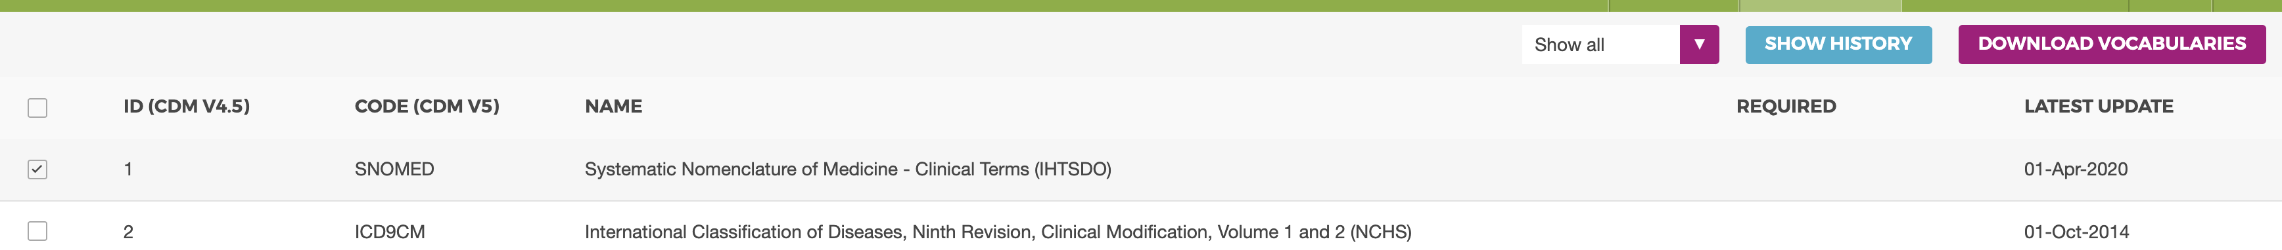

Be sure to check SNOMED, then Download Vocabularies

Then, wait until the download is ready at https://athena.ohdsi.org/vocabulary/download-history:

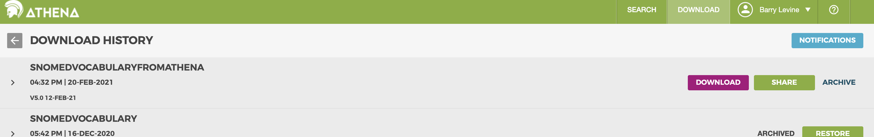

The download will create a zip file like vocabulary_download_v5_{8c5131e2-9350-4549-a813-3da924313182}_1613867923031.zip

Unzip this file. You’ll see a file structure similar to the following:

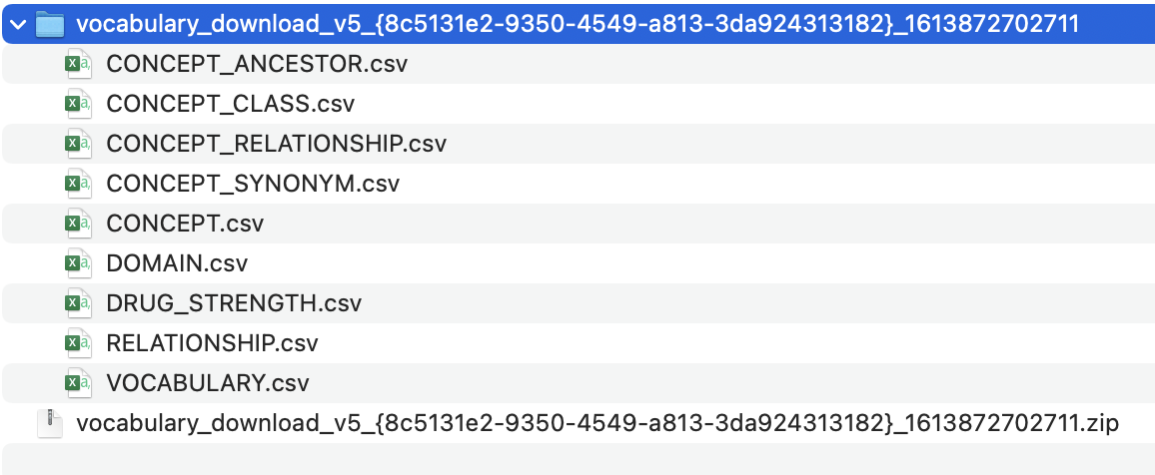

# Set up the Common-Data-Model/PostgreSQL database and populate the database with the Snomed Vocabulary

Refer to the following steps

Browse to <https://github.com/sikder-sab/OPENMRS_OMOP_PROJECT/tree/main/PostgreSQL>

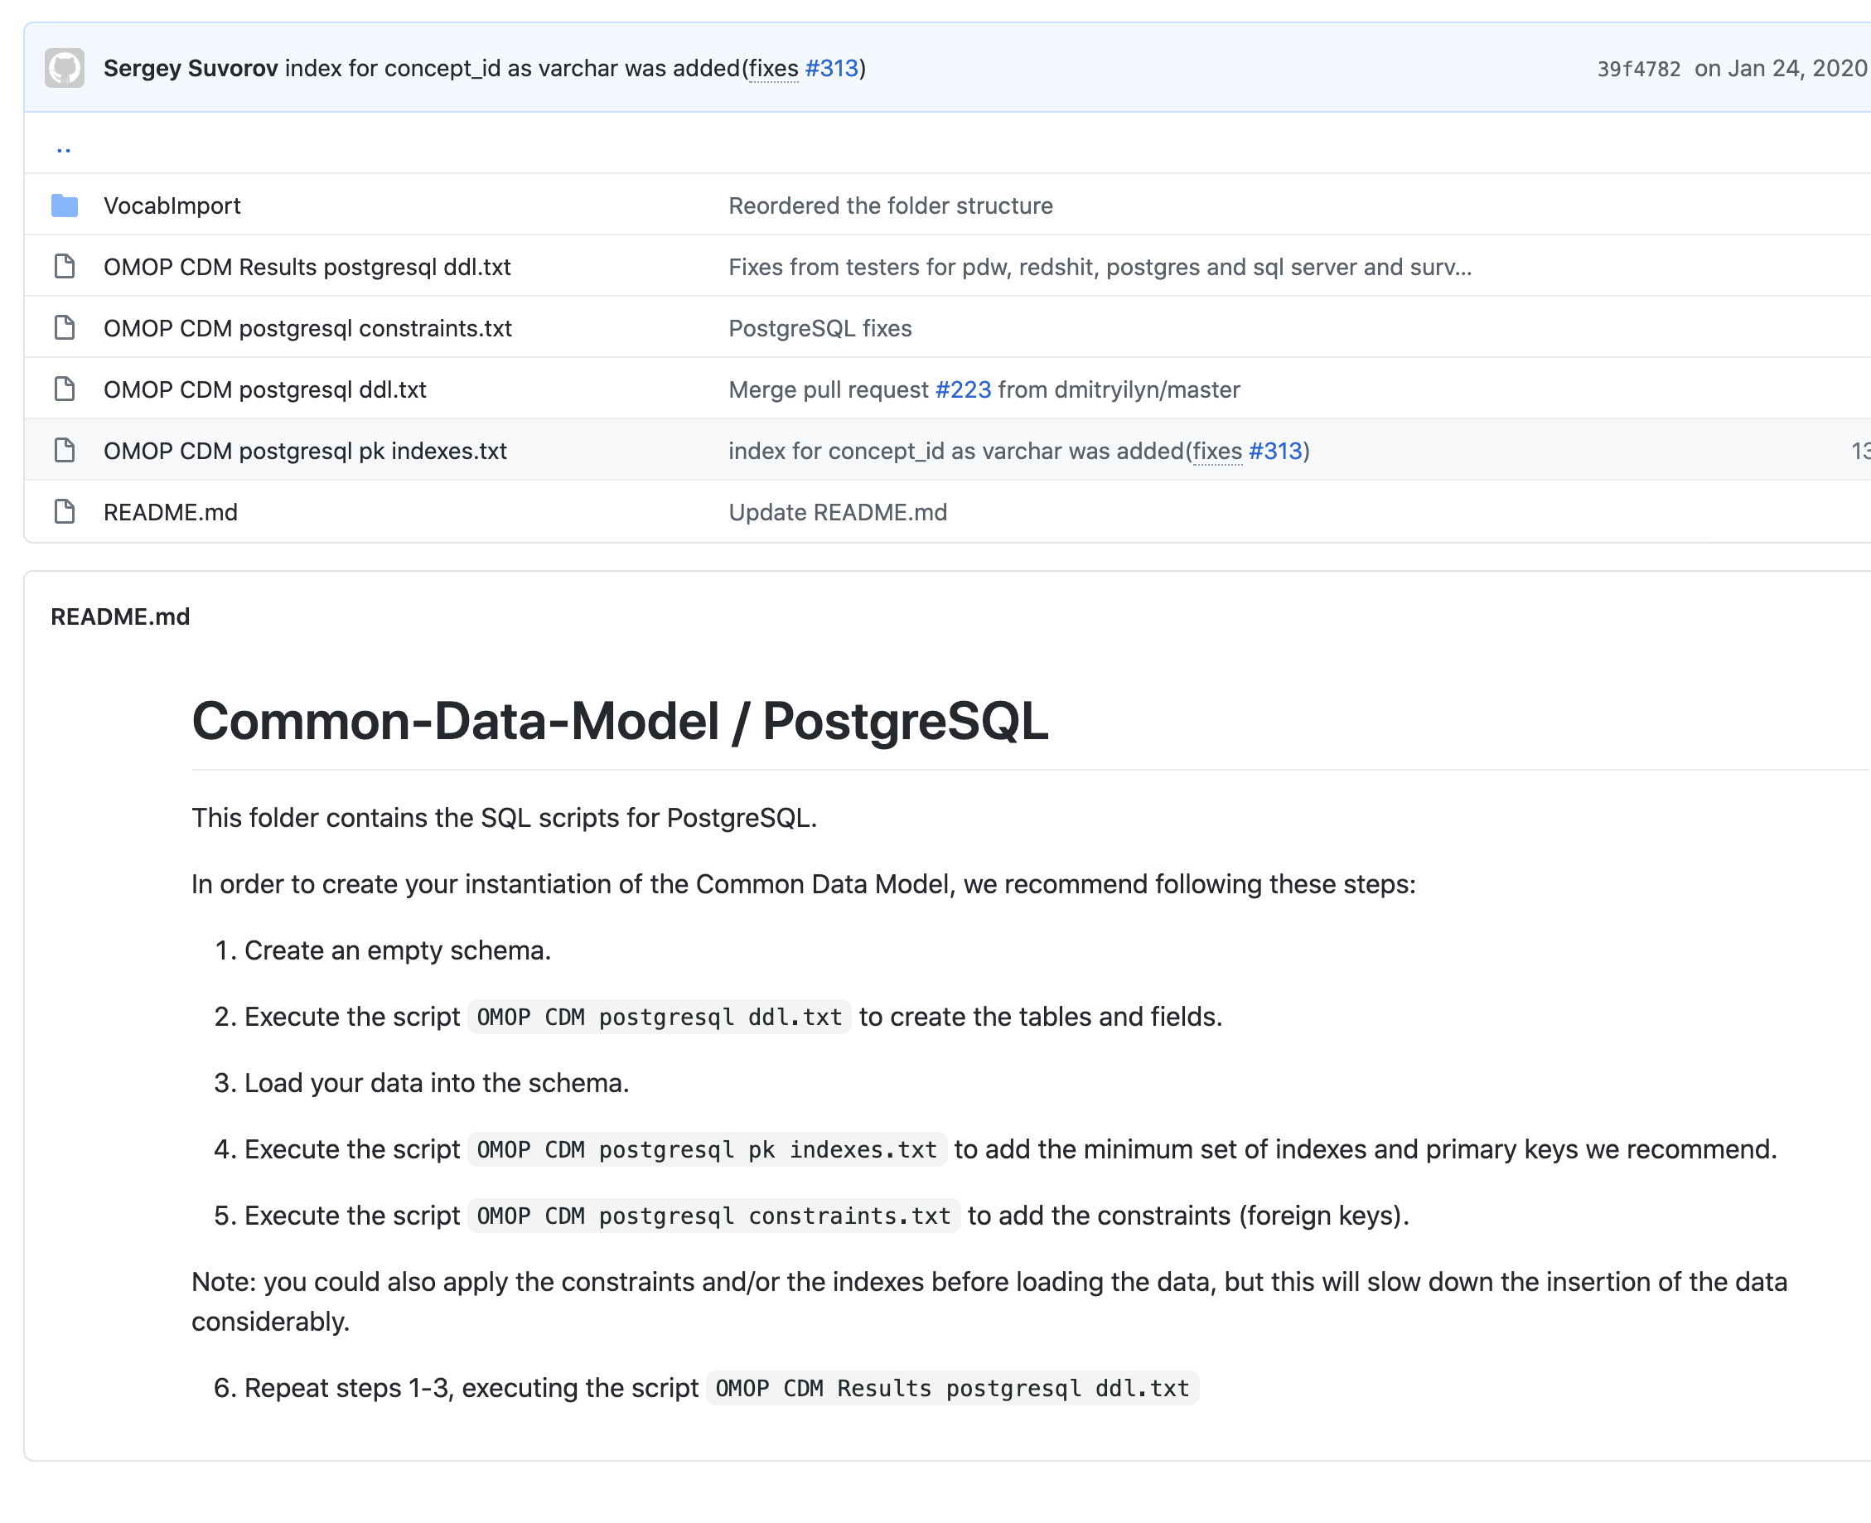

Follow the steps listed above

1. Already created schema (op1)
2. Select script file and execute in pgadmin:



Open query tool, below

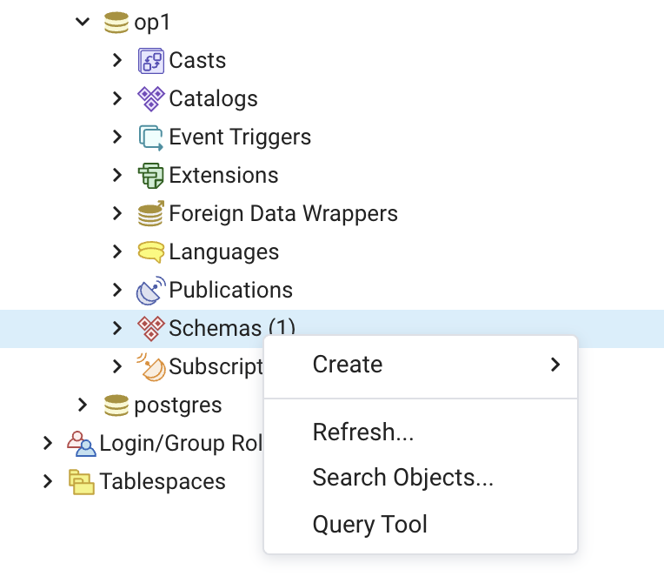

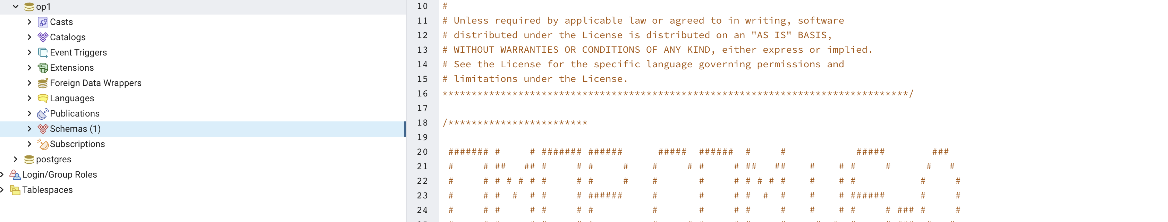

After the script executes you can see the tables that have been created:

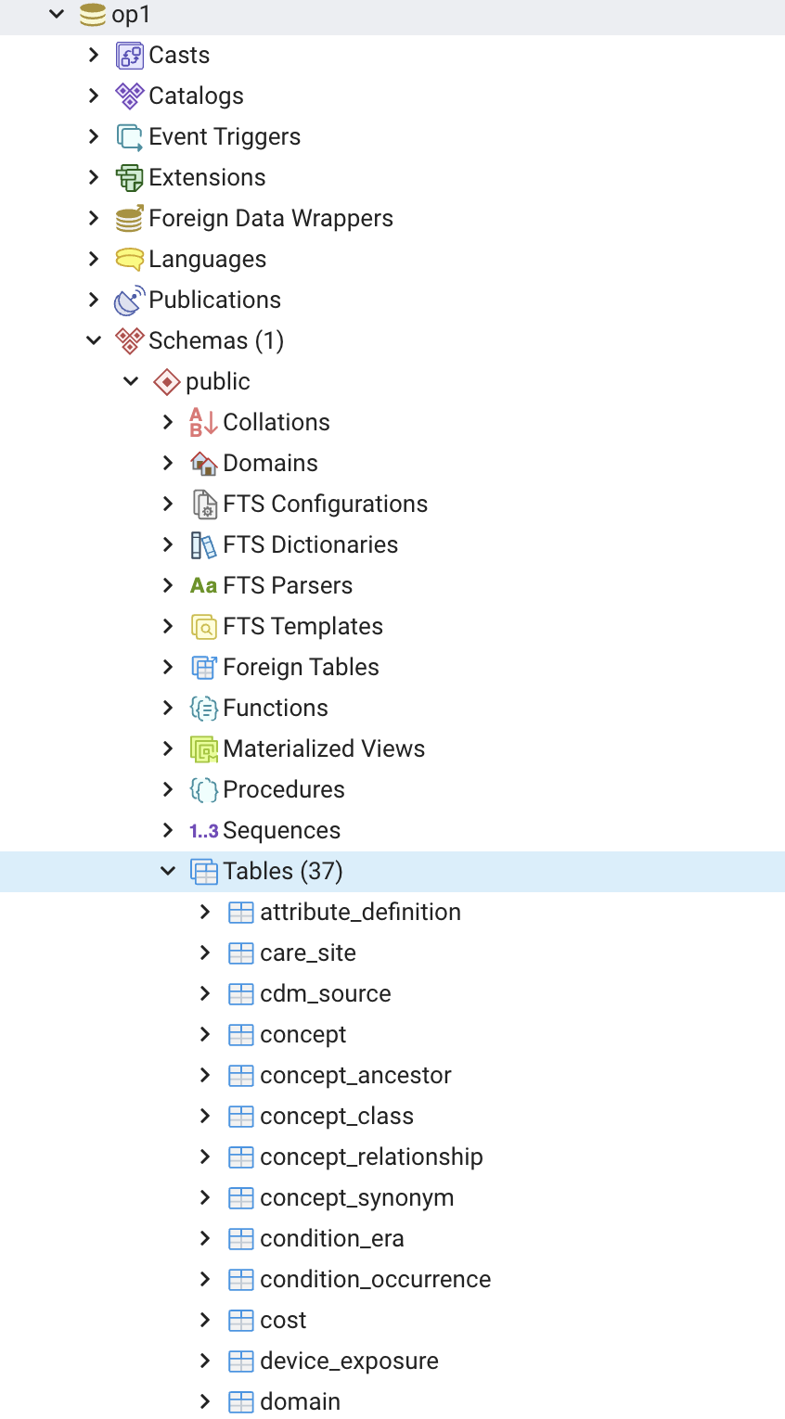

1. Load your data into the schema



Select VocabImport to get the sql query for loading the data



This file contains the following queries:

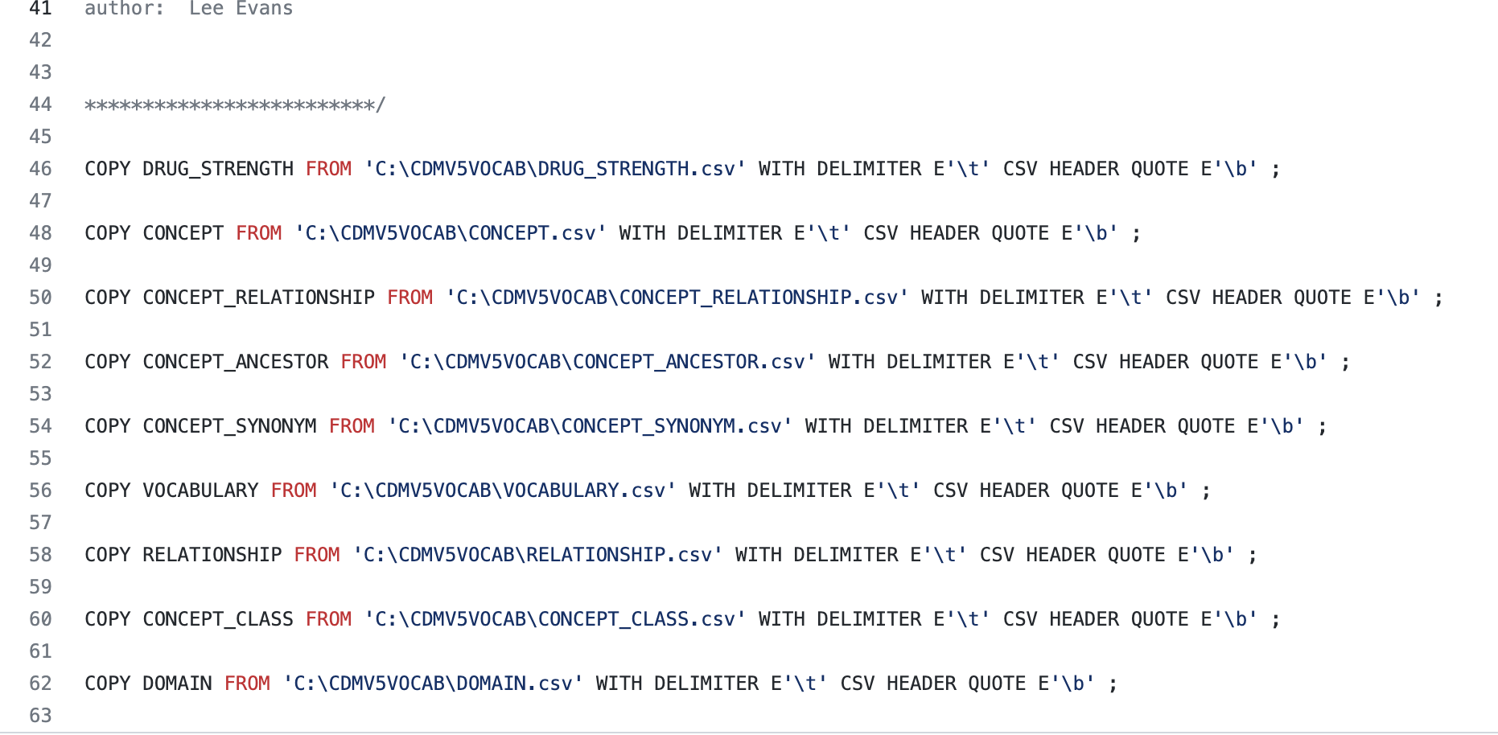

You will need to modify the file paths in this .sql file to reflect where you downloaded the Athena Snomed Vocabulary.

For example, I modified the file as follows:

COPY DRUG_STRENGTH FROM '/Users/xxx/OpenMRS/xxx/OMOP/xxx/PostgresSetup/AthenaVocabularies/CDMV5VOCAB/DRUG_STRENGTH.csv' WITH DELIMITER E'\t' CSV HEADER QUOTE E'\b' ;

COPY CONCEPT FROM '/Users/xxx/OpenMRS/xxx/OMOP/xxx/PostgresSetup/AthenaVocabularies/CDMV5VOCAB/CONCEPT.csv' WITH DELIMITER E'\t' CSV HEADER QUOTE E'\b' ;

…

Be sure to execute each query, above, in a query window.

It will take about 10 minutes to complete.



1. Execute the script OMOP CDM postgresql pk indexes.txt to add the minimum set of indexes and primary keys we recommend.
2. Execute the script OMOP CDM postgresql constraints.txt to add the constraints (foreign keys).
3. Ignore this step

Next, we need to modify some of the PostgreSQL tables in the op2 schema.

Modify location table to match the following:

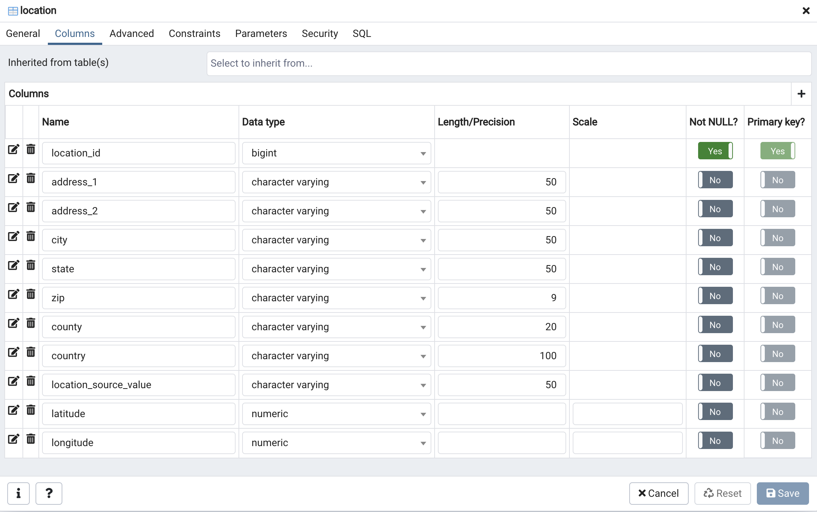

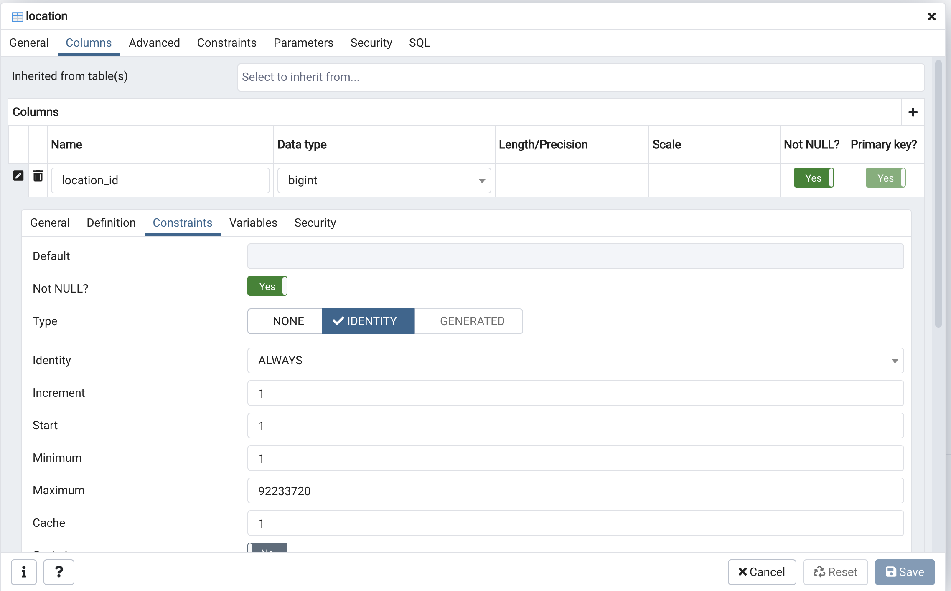

observation_period

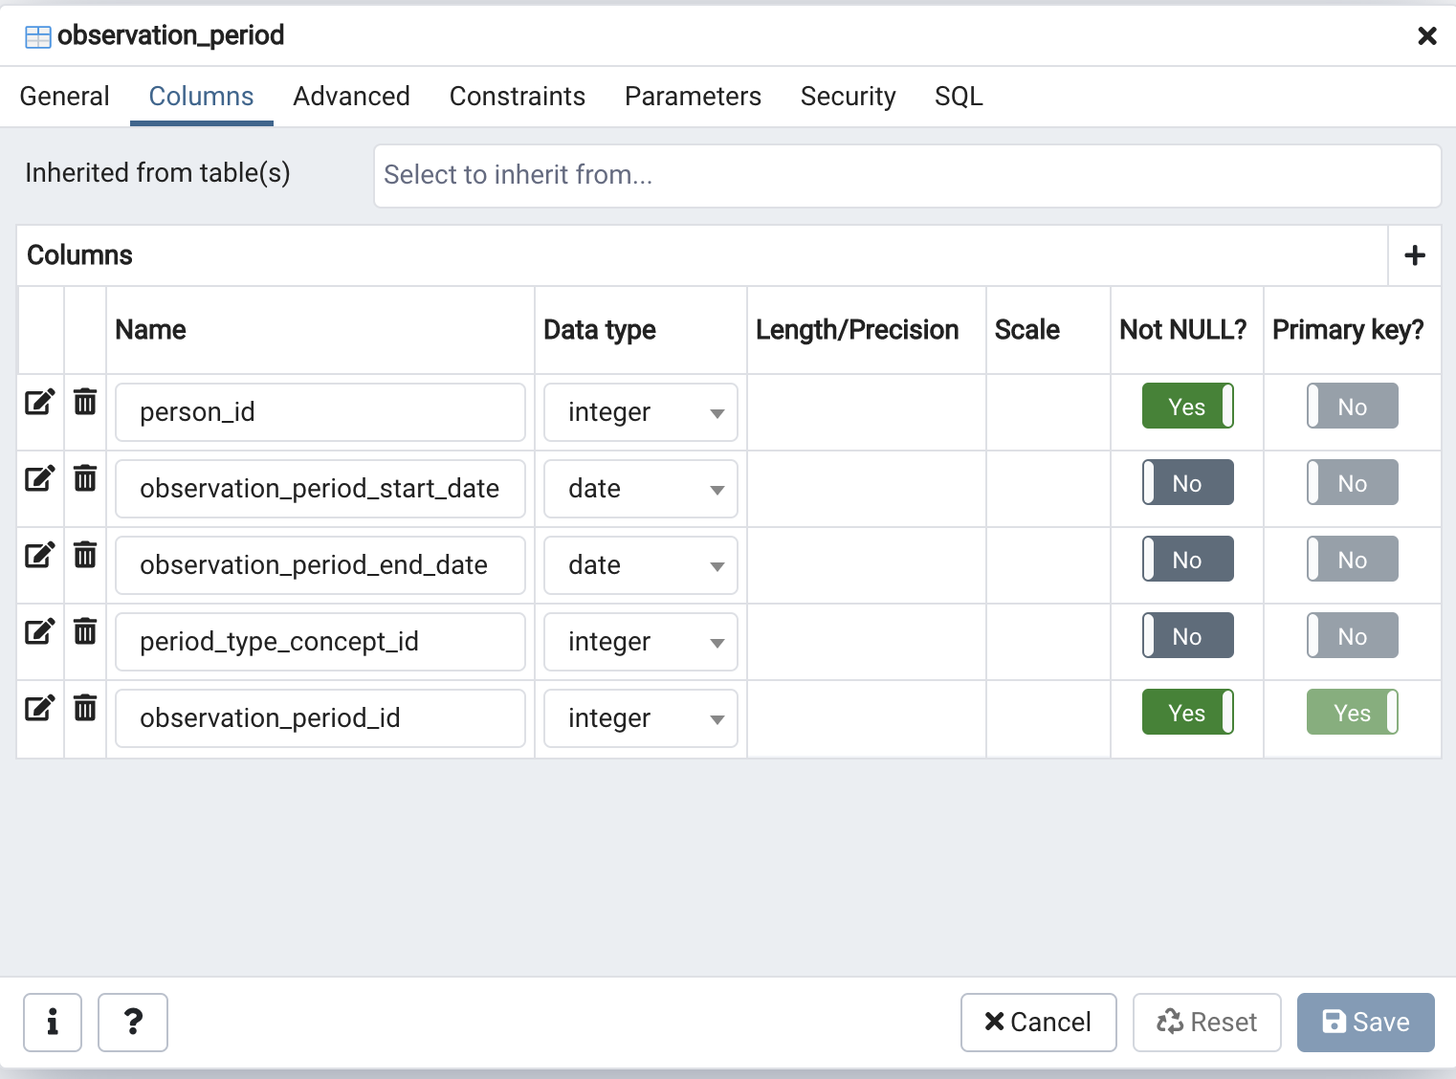

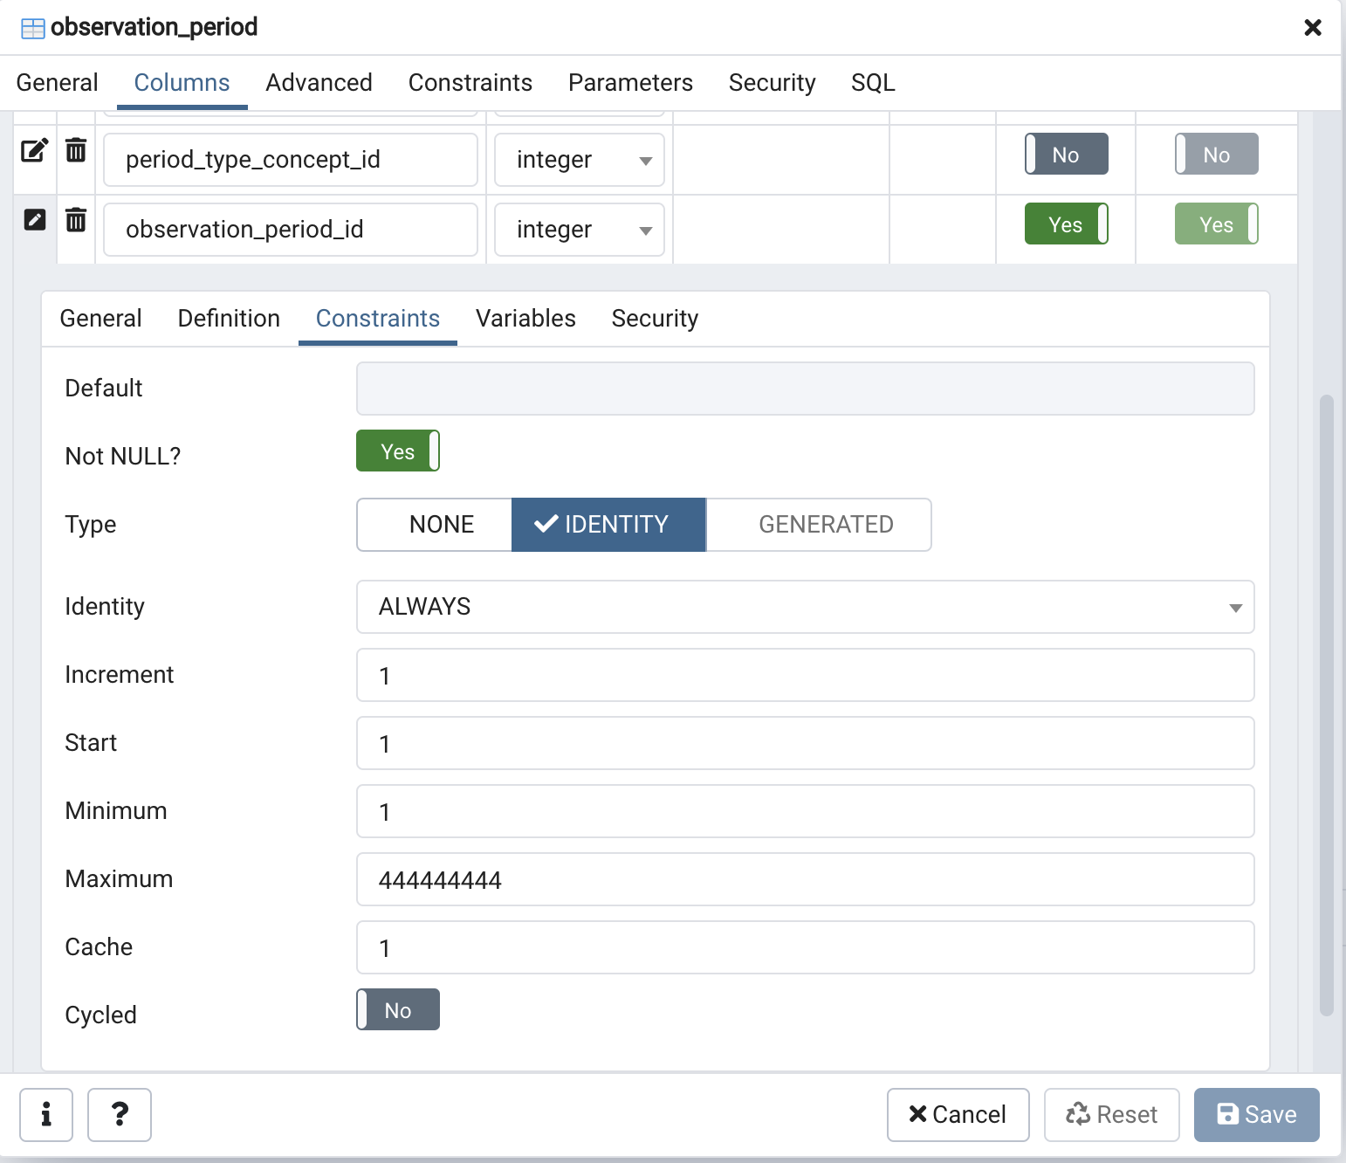

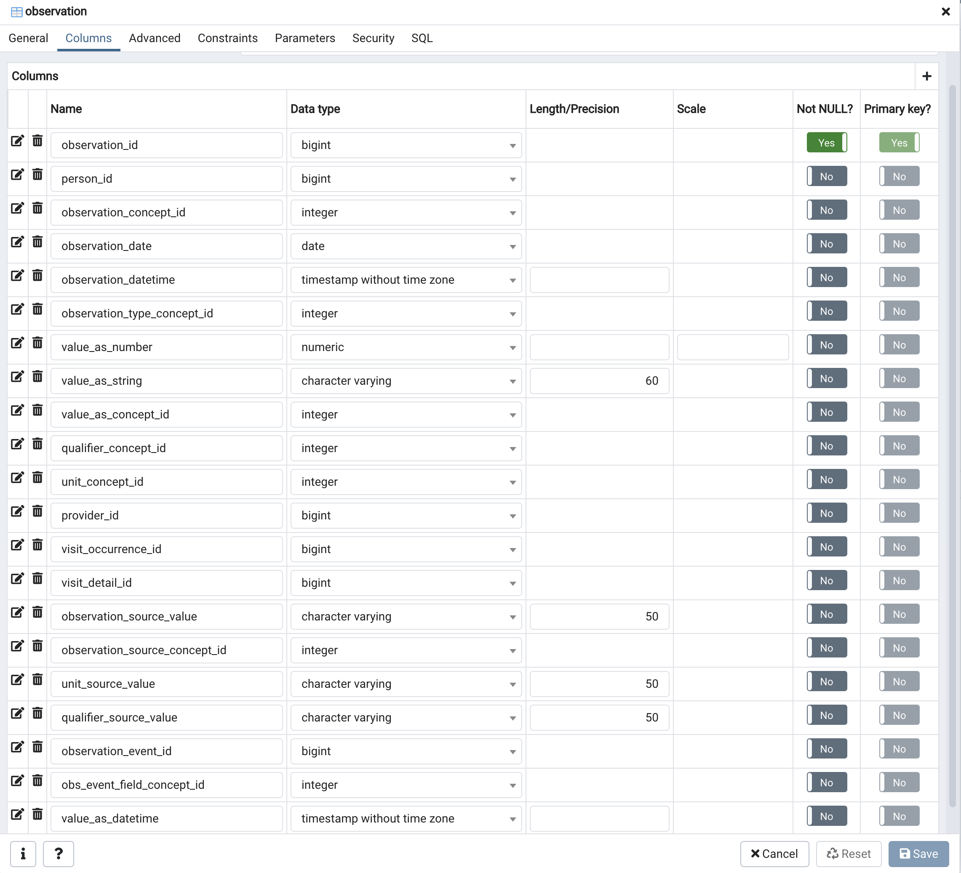

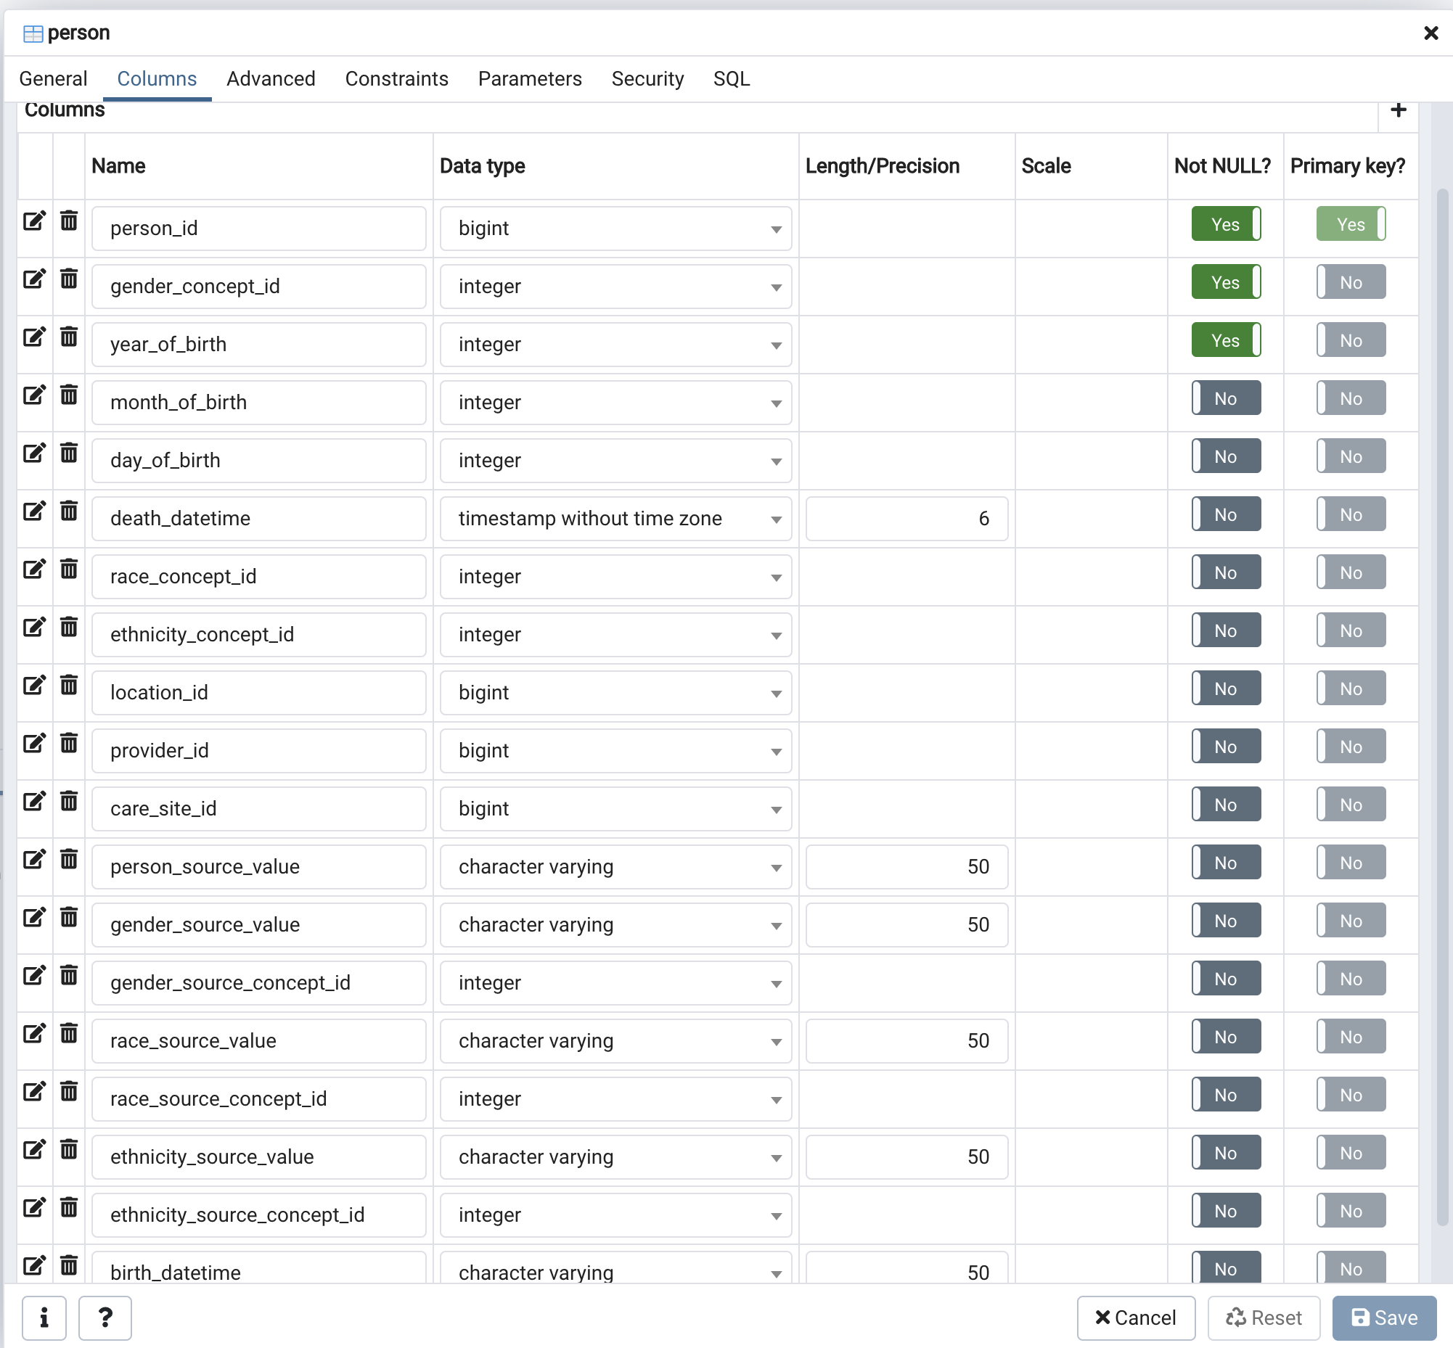

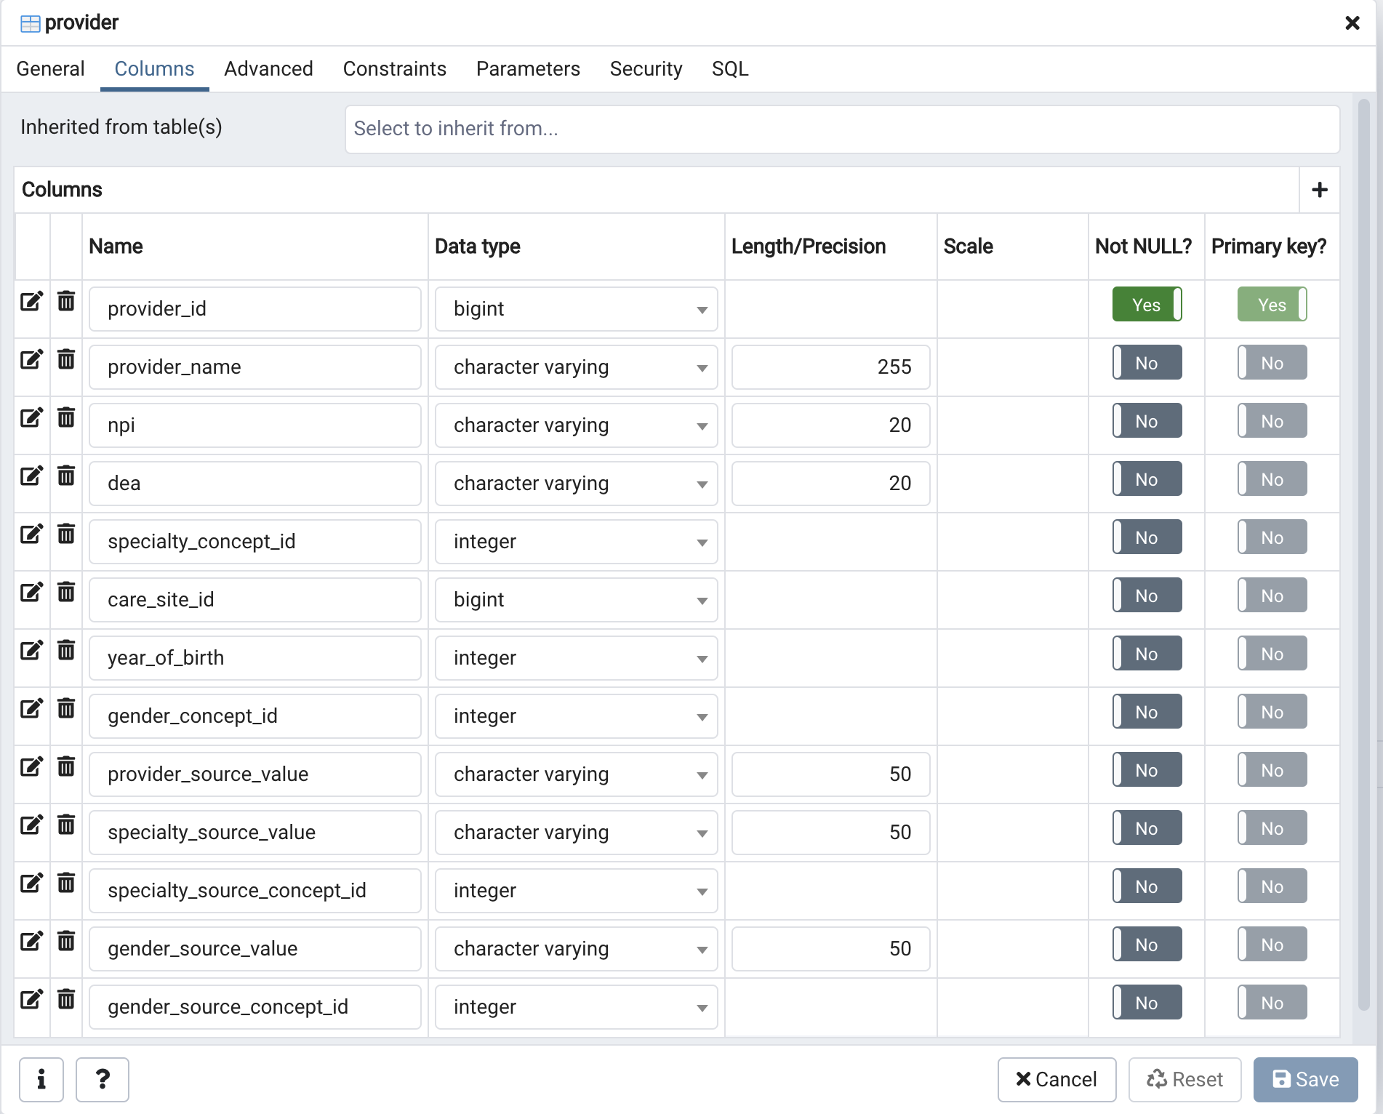

CREATE TABLE “death” to record patient deaths:

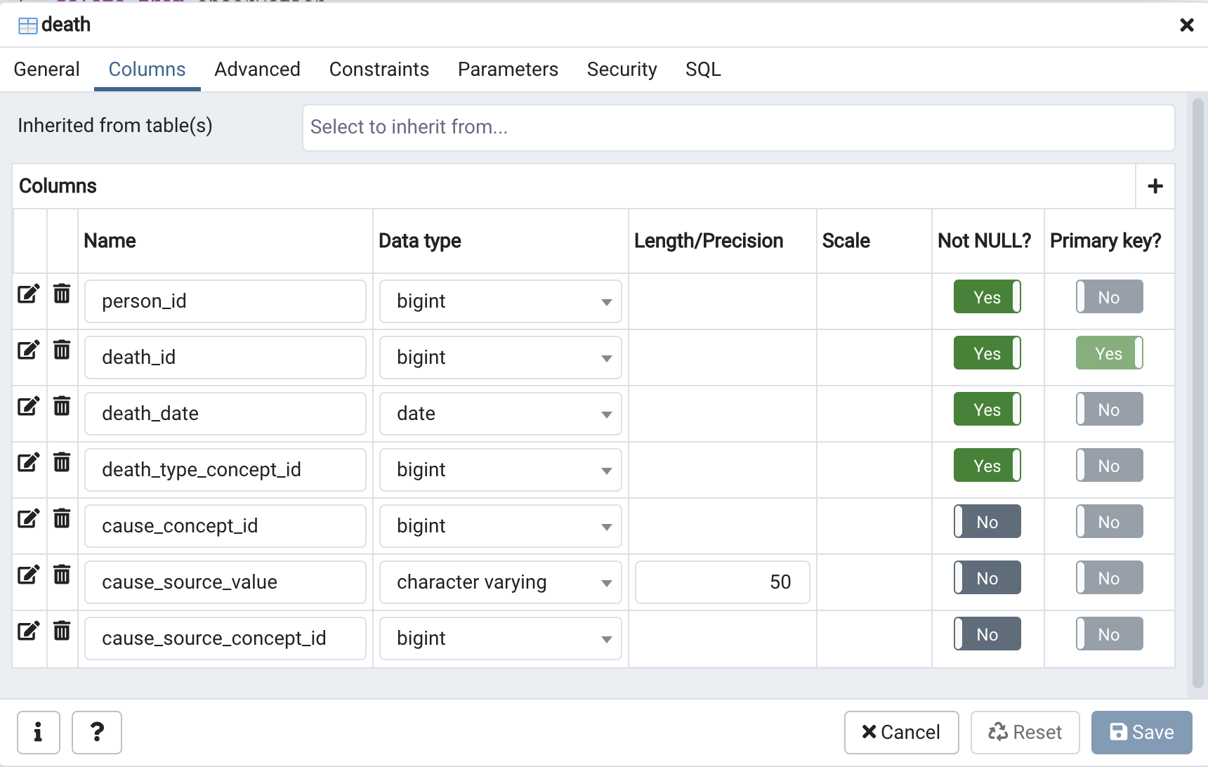

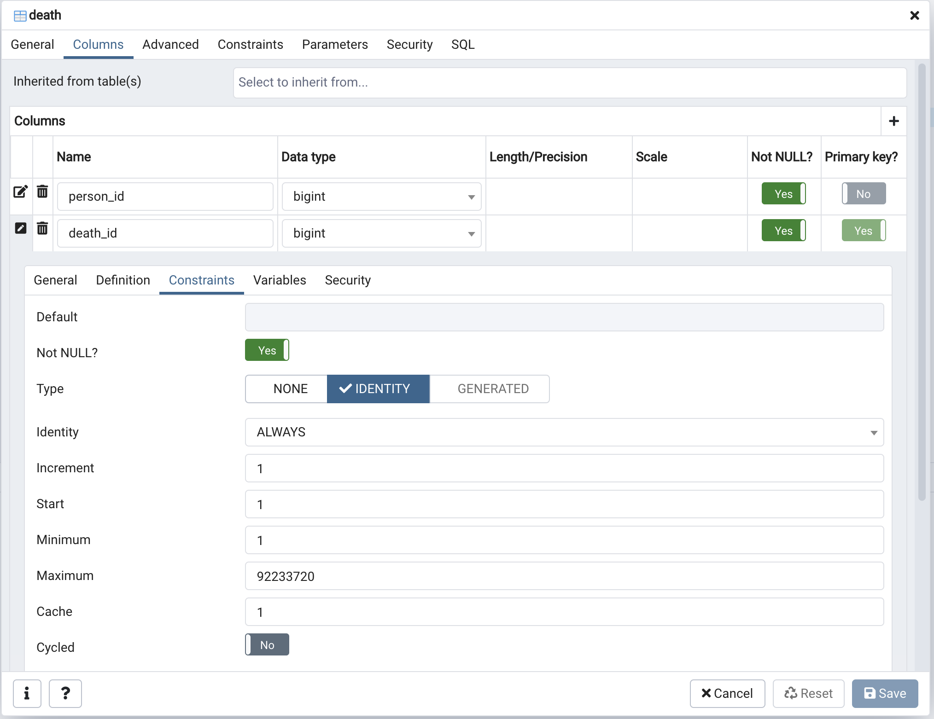

# Set up Talend – create jobs to move data from source to target

In this section we will provide an introduction to setting up Talend to move the OpenMRS demo database (source, mysql) to the OMOP database (target, PostgreSQL).

Start Talend and you will see something like:

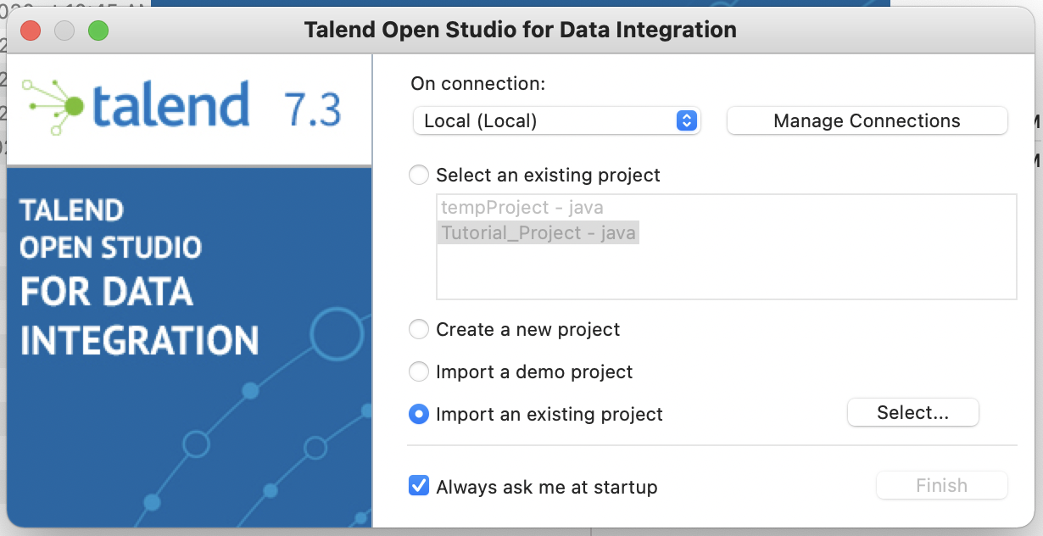

You will import our project. Then browse to the folder containing the project. The project is found here: <https://github.com/sikder-sab/OPENMRS_OMOP_PROJECT>

The name of the project is CHLA_OMOP_PROJECT. Download the zip file and unzip it in your directory of choice (this will be the project root directory – see below).

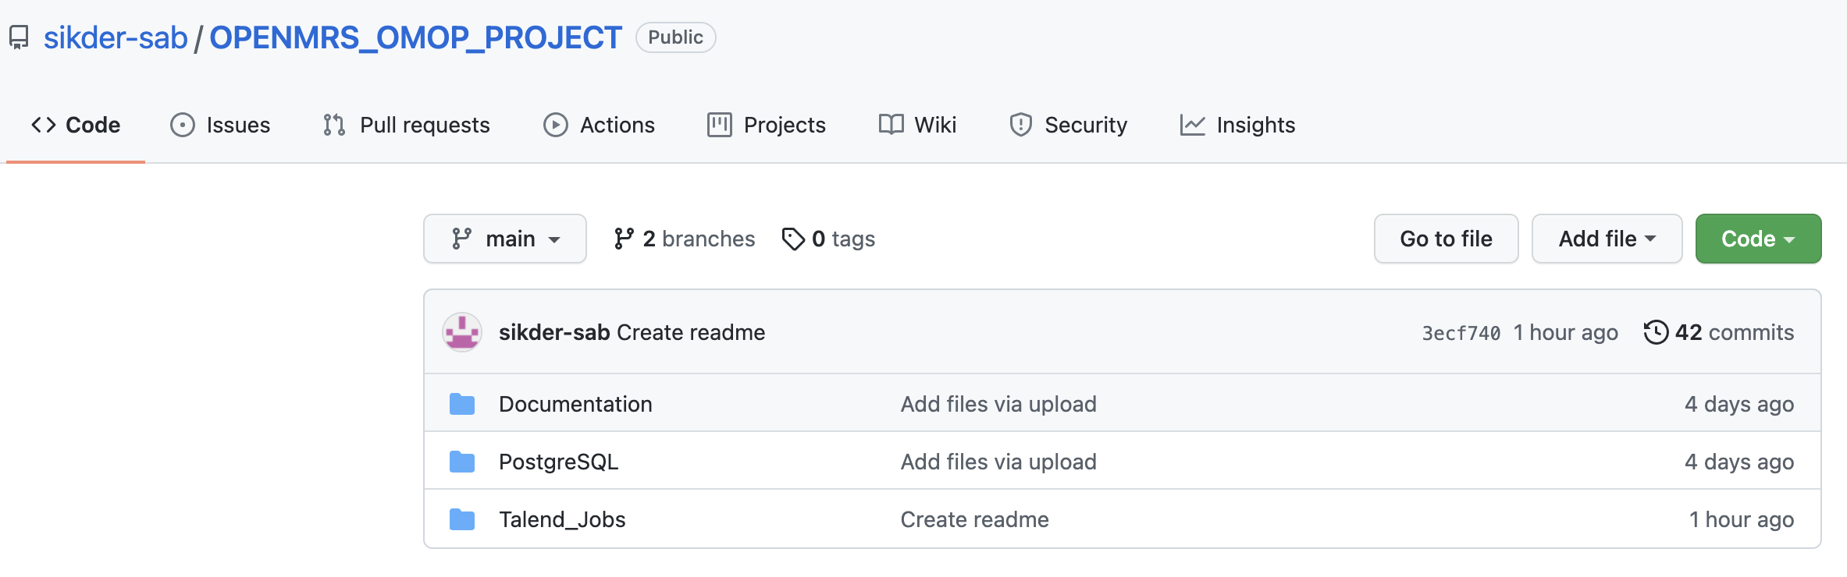

Select the *Code* button. Download the entire folder contents as a zip file:

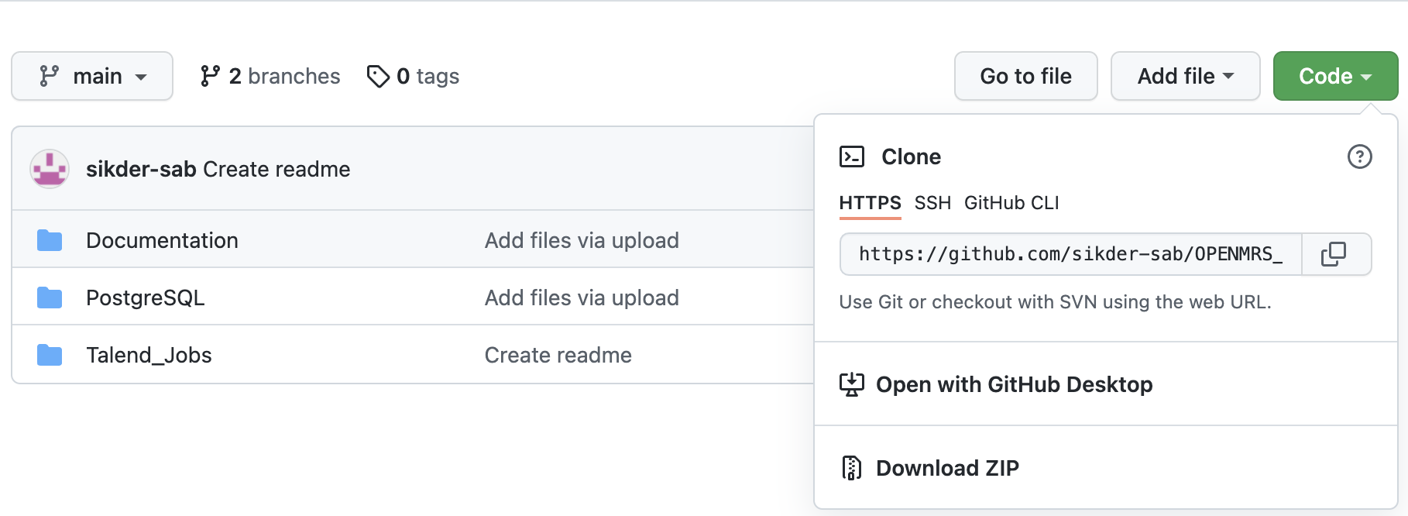

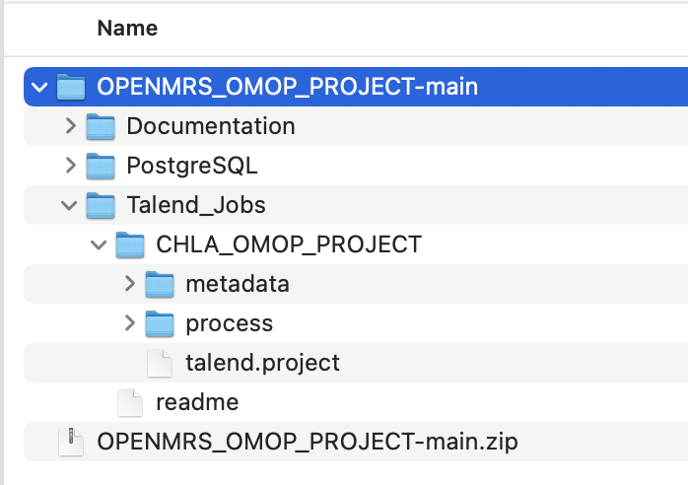

We’re interested in the folder *CHLA_OMOP_PROJECT*, but without the *readme*.

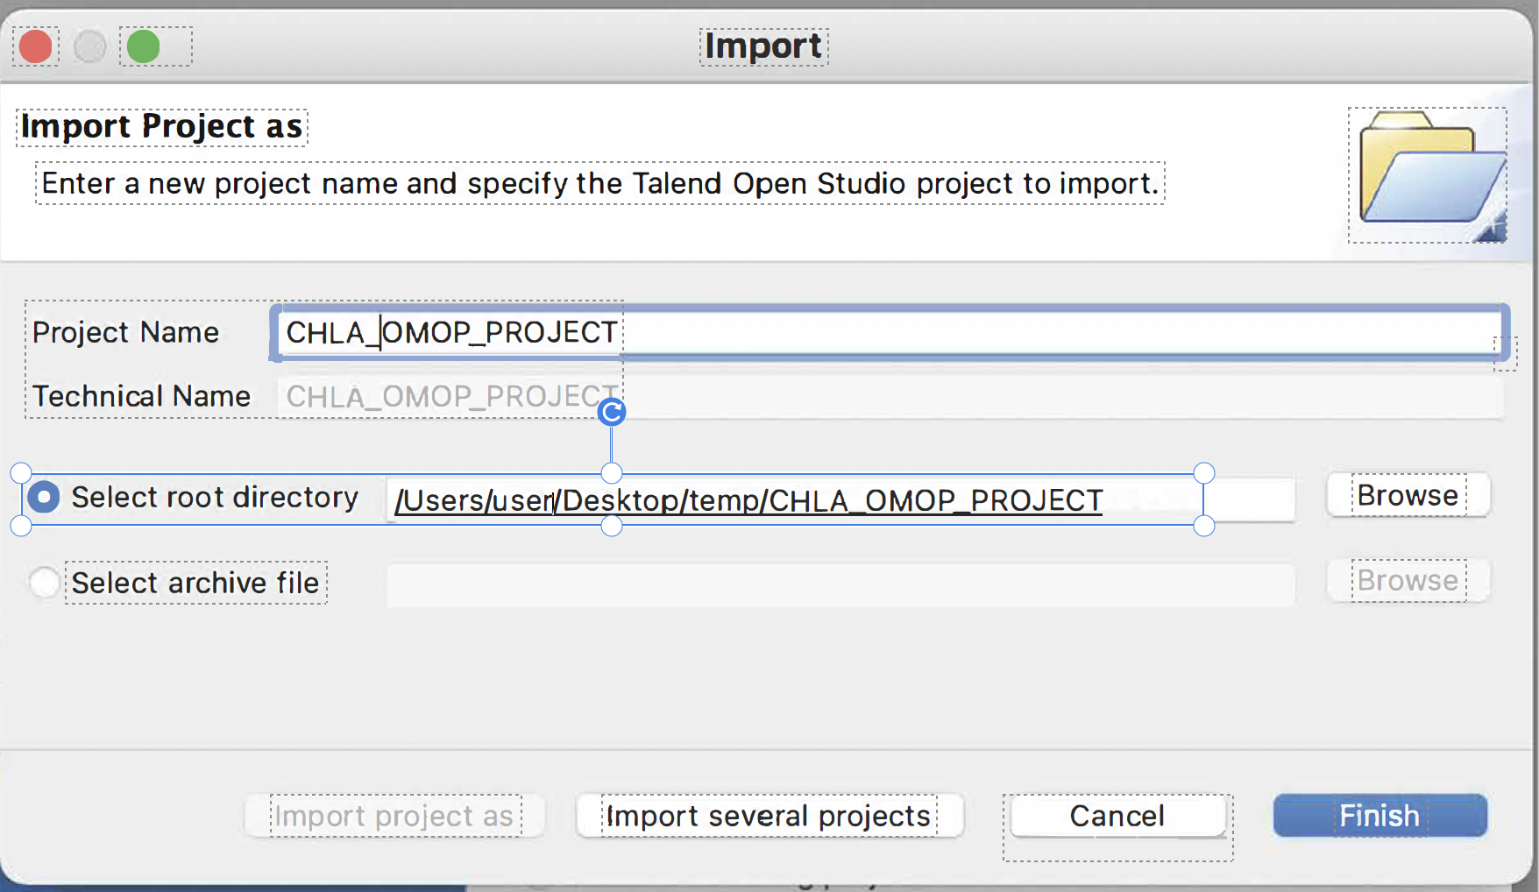

Next, select “Finish”.

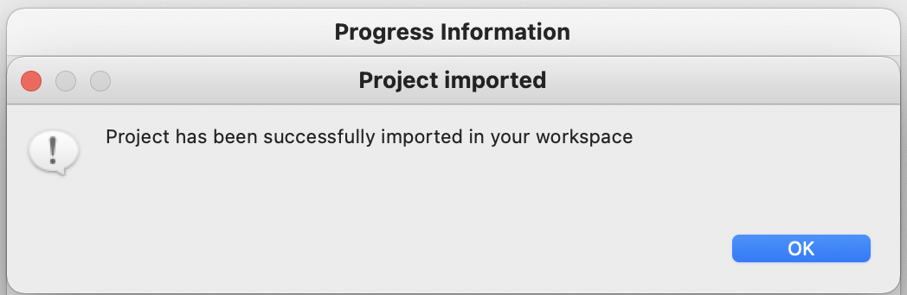

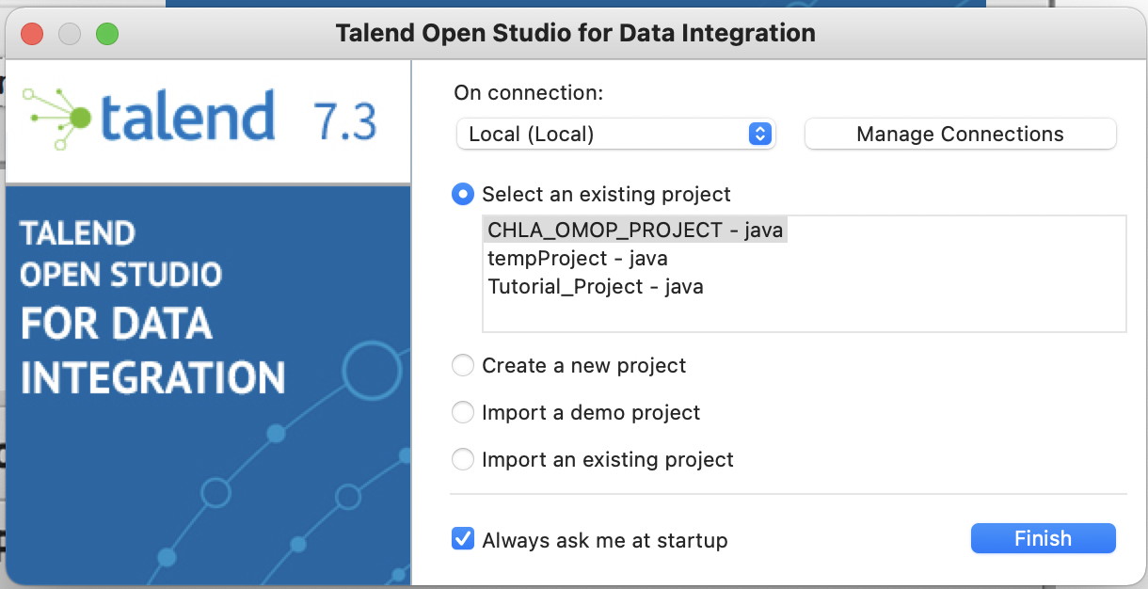

Select CHLA_OMOP_PROJECT – java, then select “Finish”

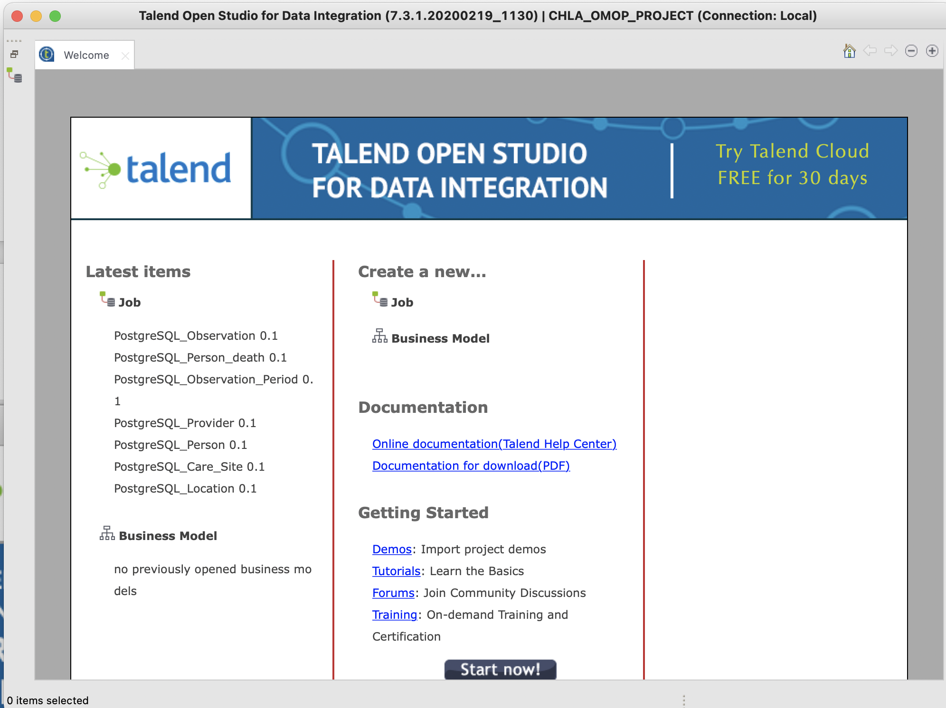

Select “Start now!”

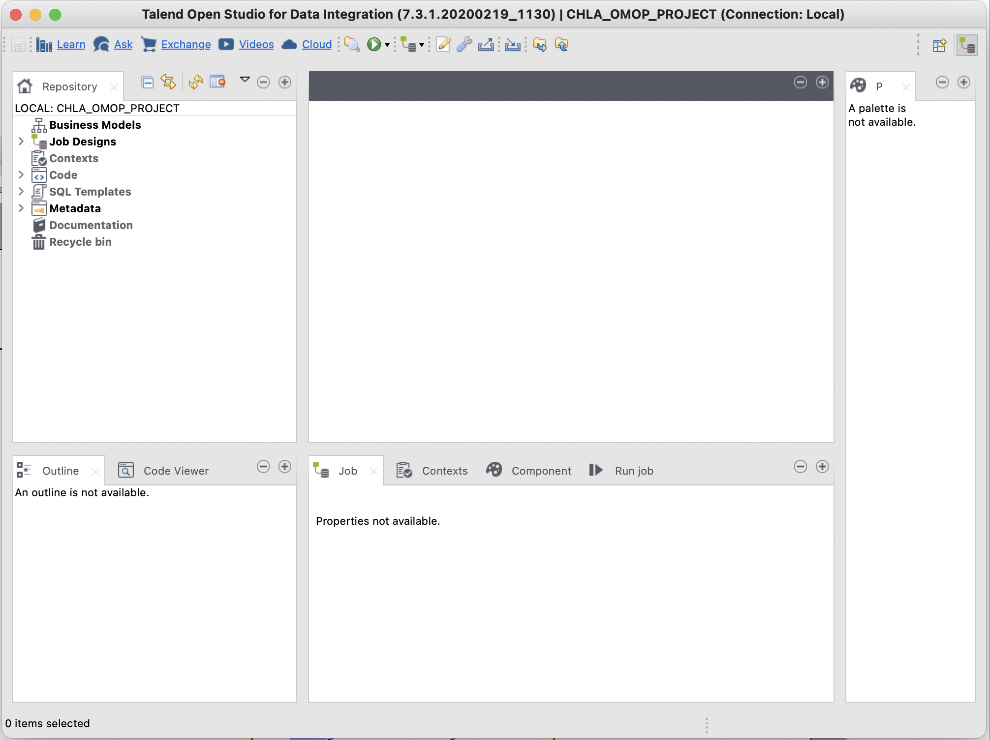

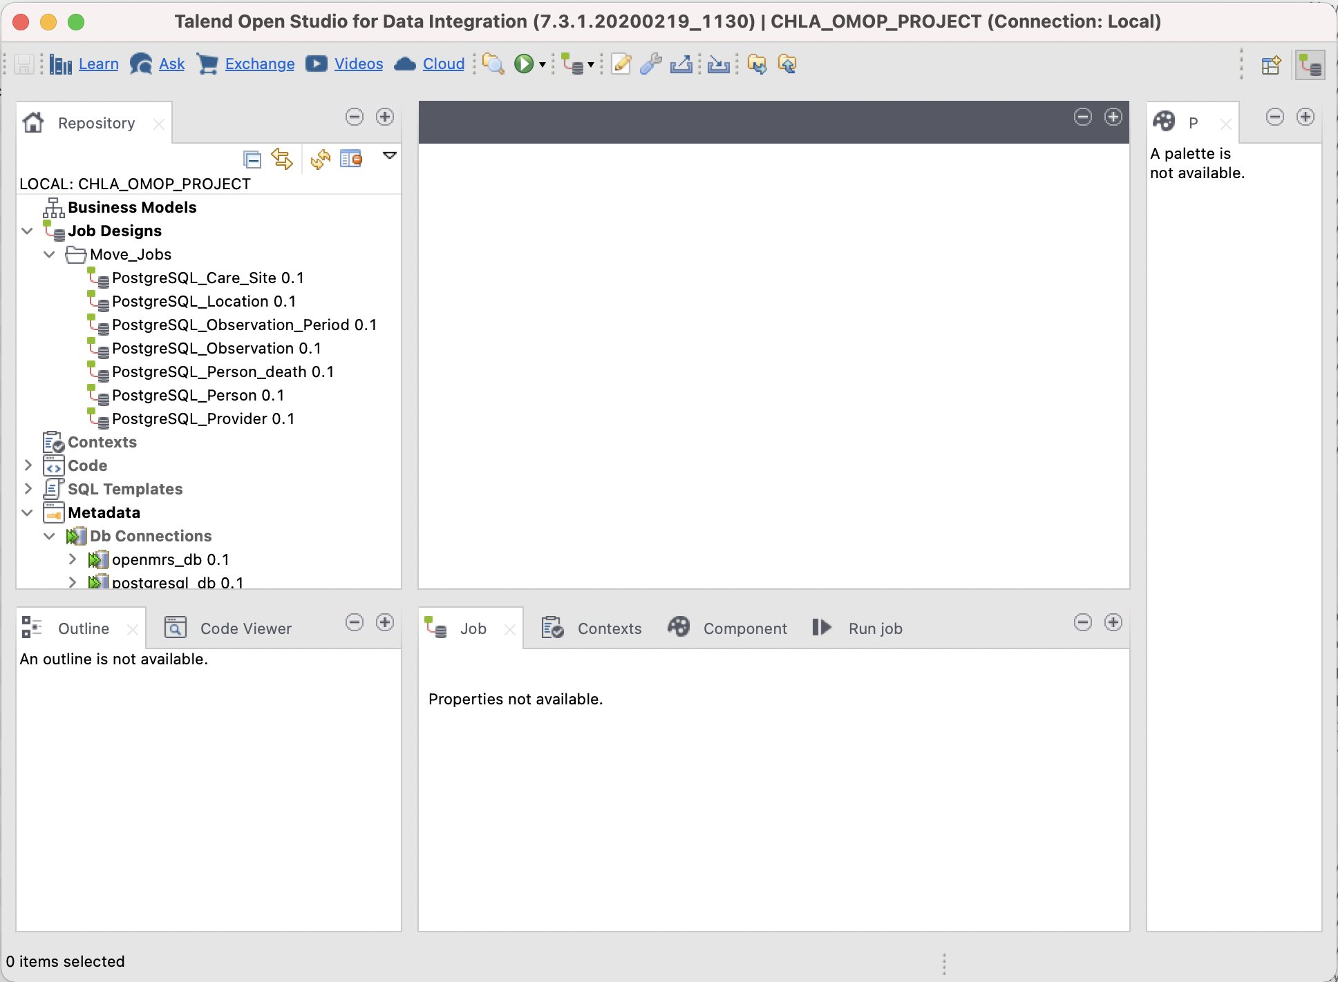

The ETL jobs must be run in the following order:

1. PostgreSQL_Location 0.1
2. PostgreSQL_Care_Site 0.1
3. PostgreSQL_Person 0.1
4. PostgreSQL_Provider 0.1
5. PostgreSQL_Observation_Period 0.1
6. PostgreSQL_Observation 0.1
7. PostgreSQL_Person_death 0.1

Note: the source is a Mysql 5 database and the target is a PostgreSQL database, as indicated in the previous section.

Source Connection Information:

Database: MySQL

DB Version: Mysql 5

Host: 127.0.0.1

Port: 3306

Database Name: openmrs

Target Connection Information:

Database: PostgreSQL

DB Version: v9 and later

Host: localhost

Port: 5432

Database Name: op1

The source/target connection information as specified in the jobs must be modified appropriately to reflect the properties you are using.

For instance, consider the connection information as specified in the PostgreSQL_Care_Site 0.1 job.

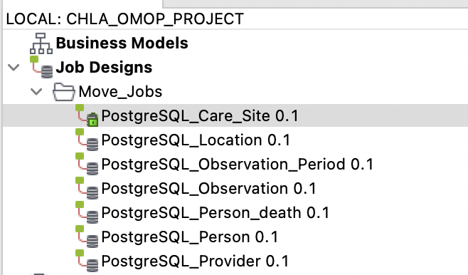

Double click on PostgreSQL_Care_Site 0.1, above, to display the job details:

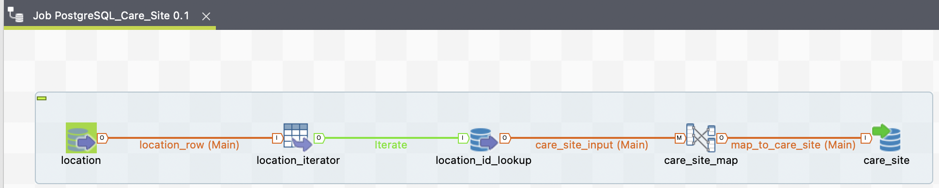

Click on the location icon to display its properties in the Component tab panel below:

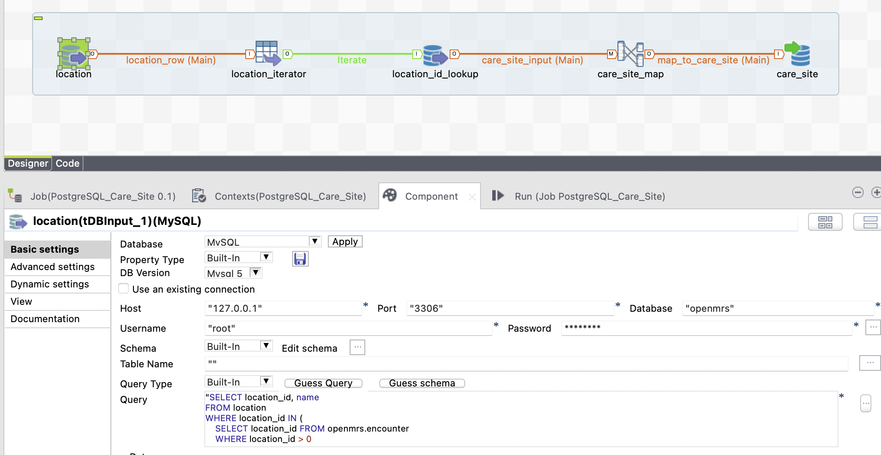

Edit the connection information (Host, Port, etc.) to reflect the properties you are using. Also, note the query used to collect the source database information to transfer to the PostgreSQL database.

Repeat this process for all of the jobs. It is strongly suggested you frequently save your edited properties using the File/Save Talend menu item.

The same process should be used for all target database icons, as well. For example, in the job PostgreSQL_Care_Site 0.1 you will need to edit the connection properties for both the *location_id_lookup* and *care_site* icons.

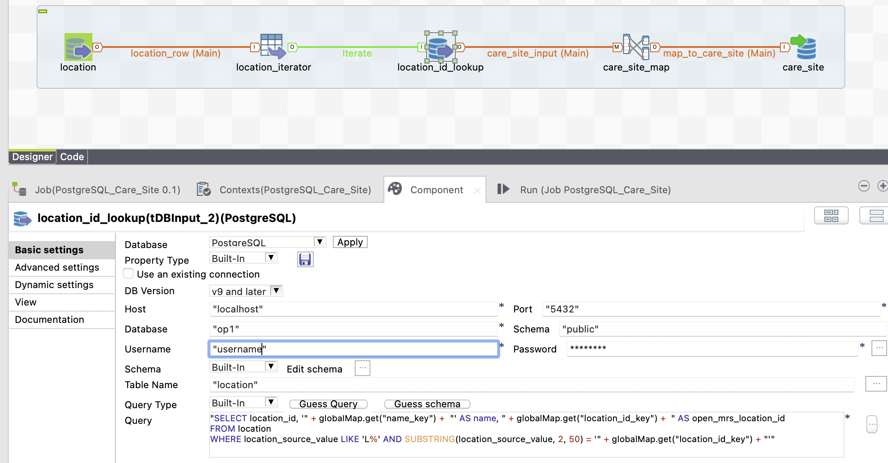

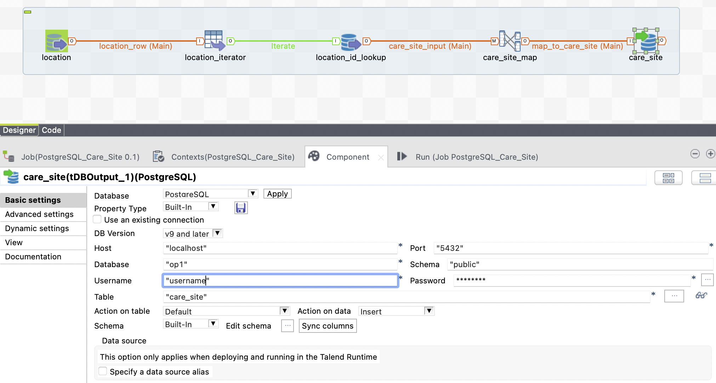

In addition to updating the connections in the jobs it’s also necessary to update the metadata connection properties. We use the metadata items in the job *PostgreSQL_Observation 0.1*

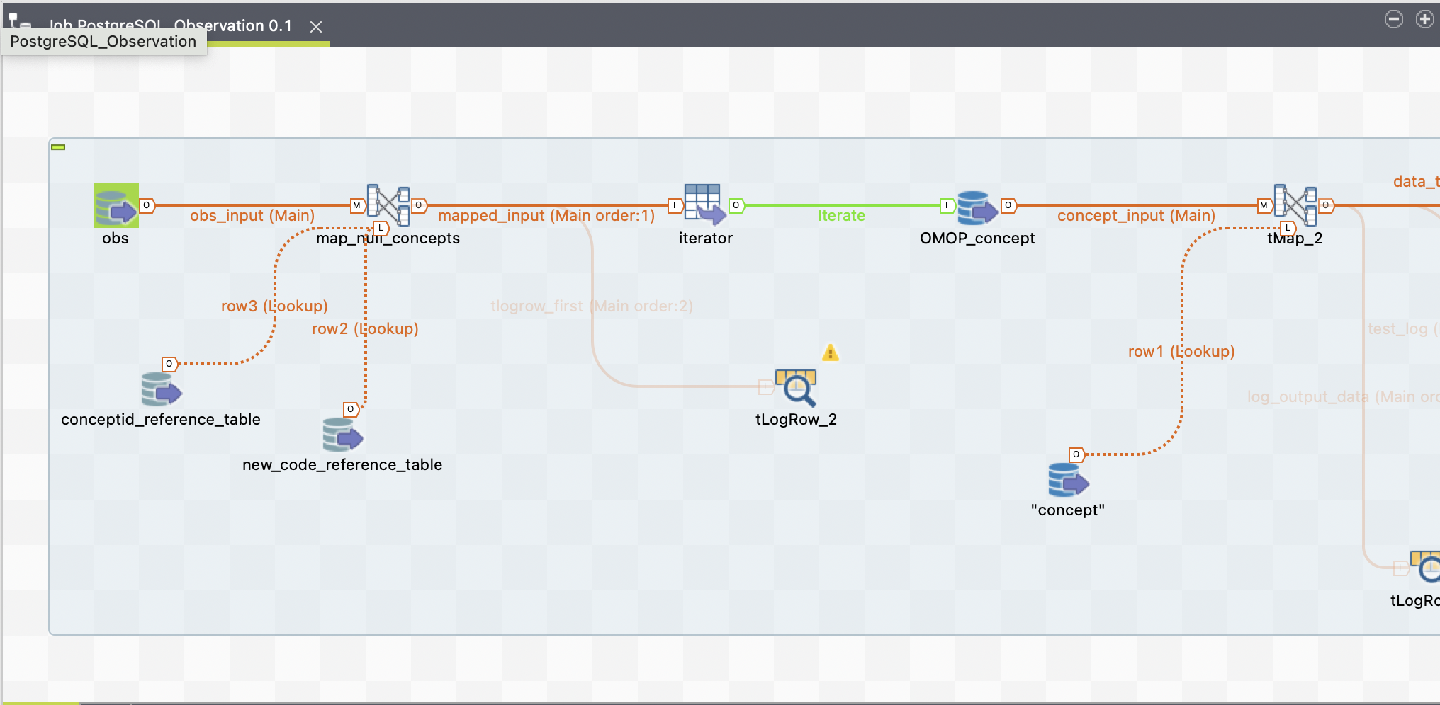

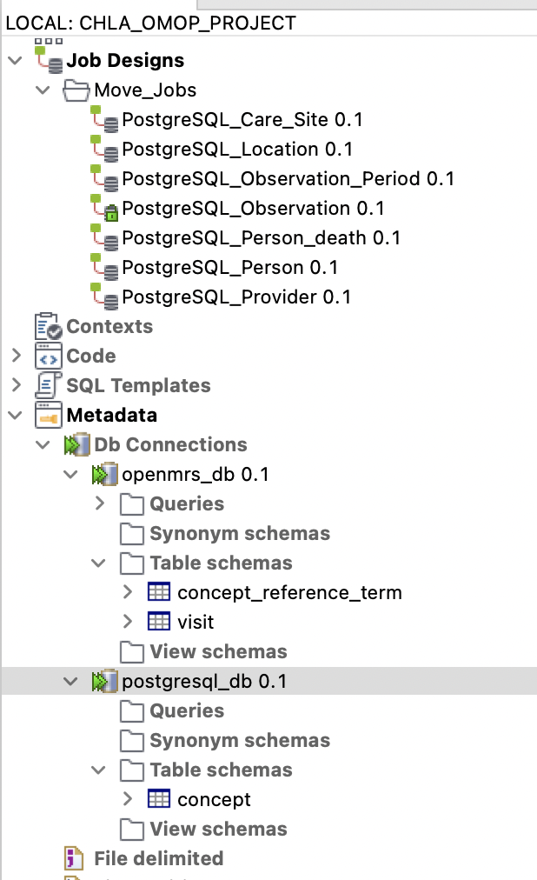

Double click on metadata item openmrs_db 0.1 to yield

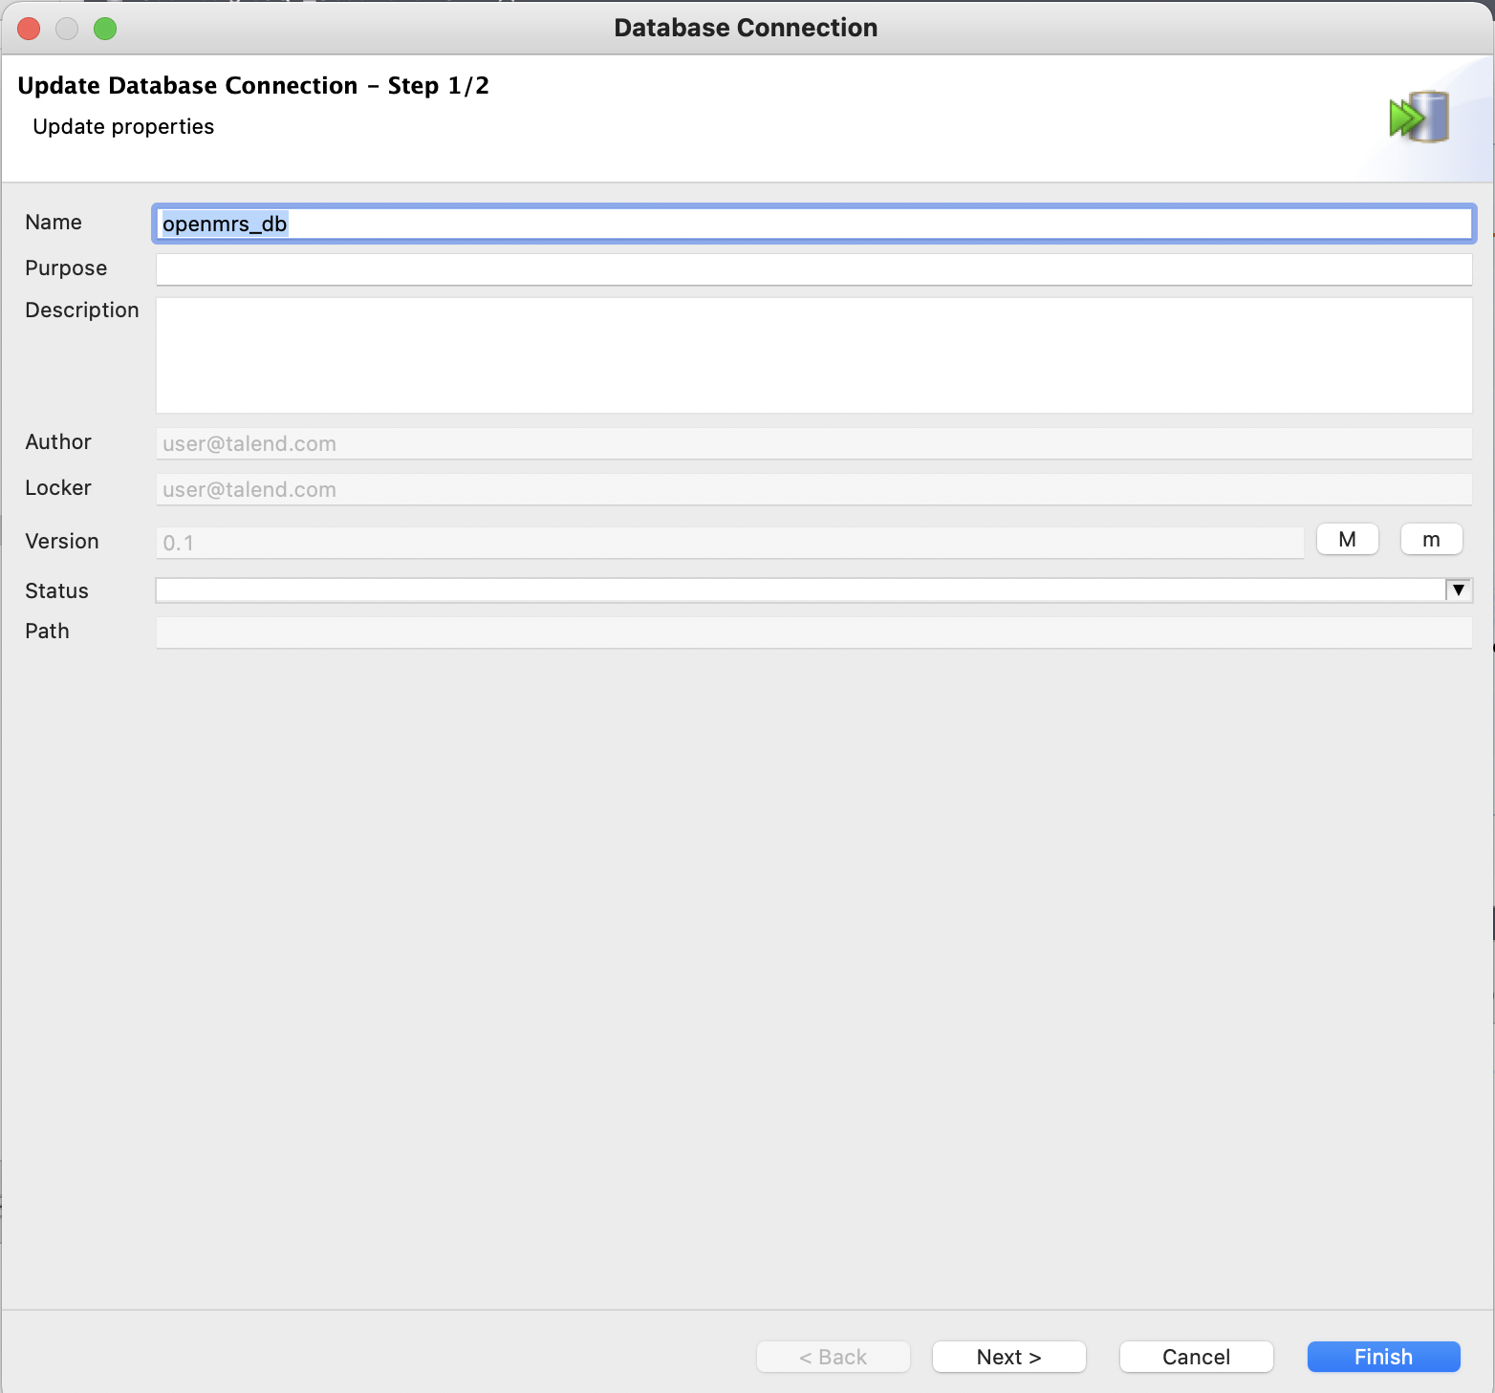

Select Next

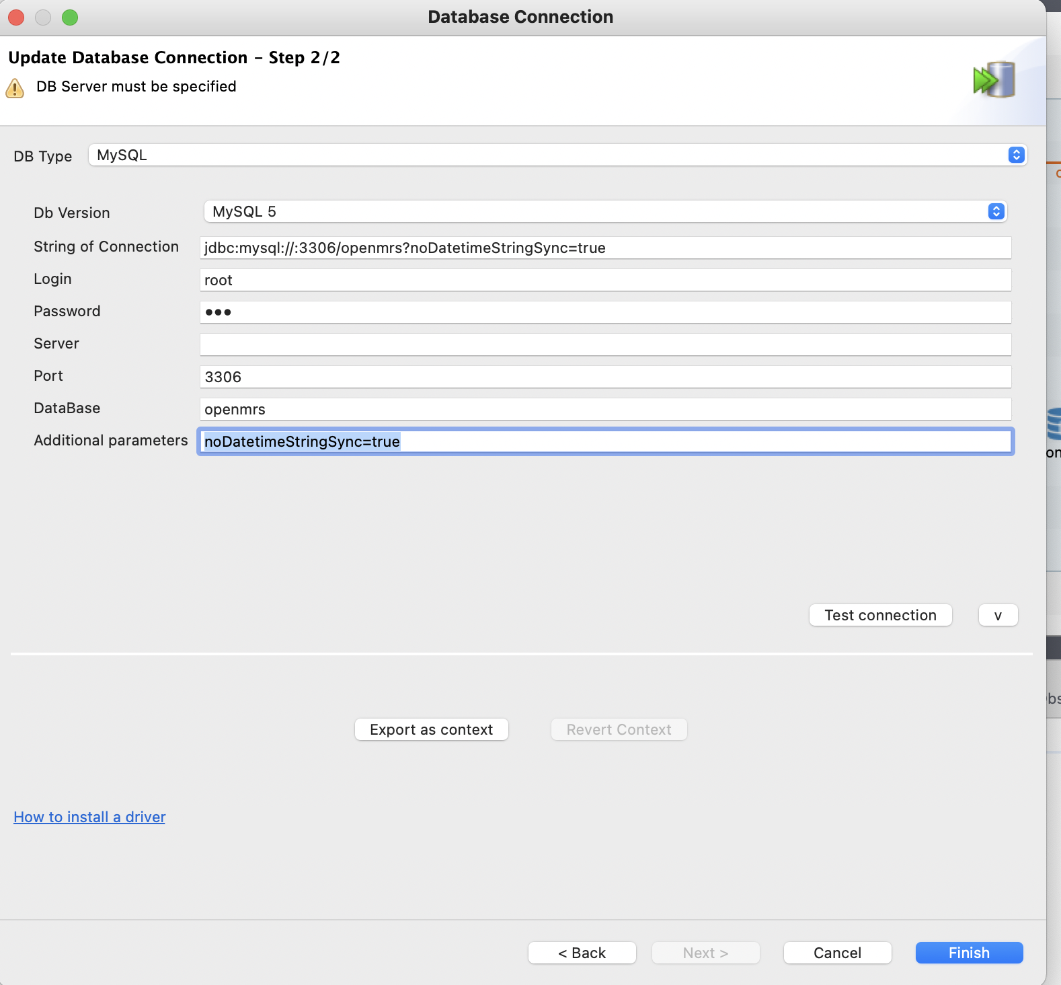

Edit the connection properties as above. Then, select *Finish*.

Note, the database name appears both in the connection string and DataBase name fields.

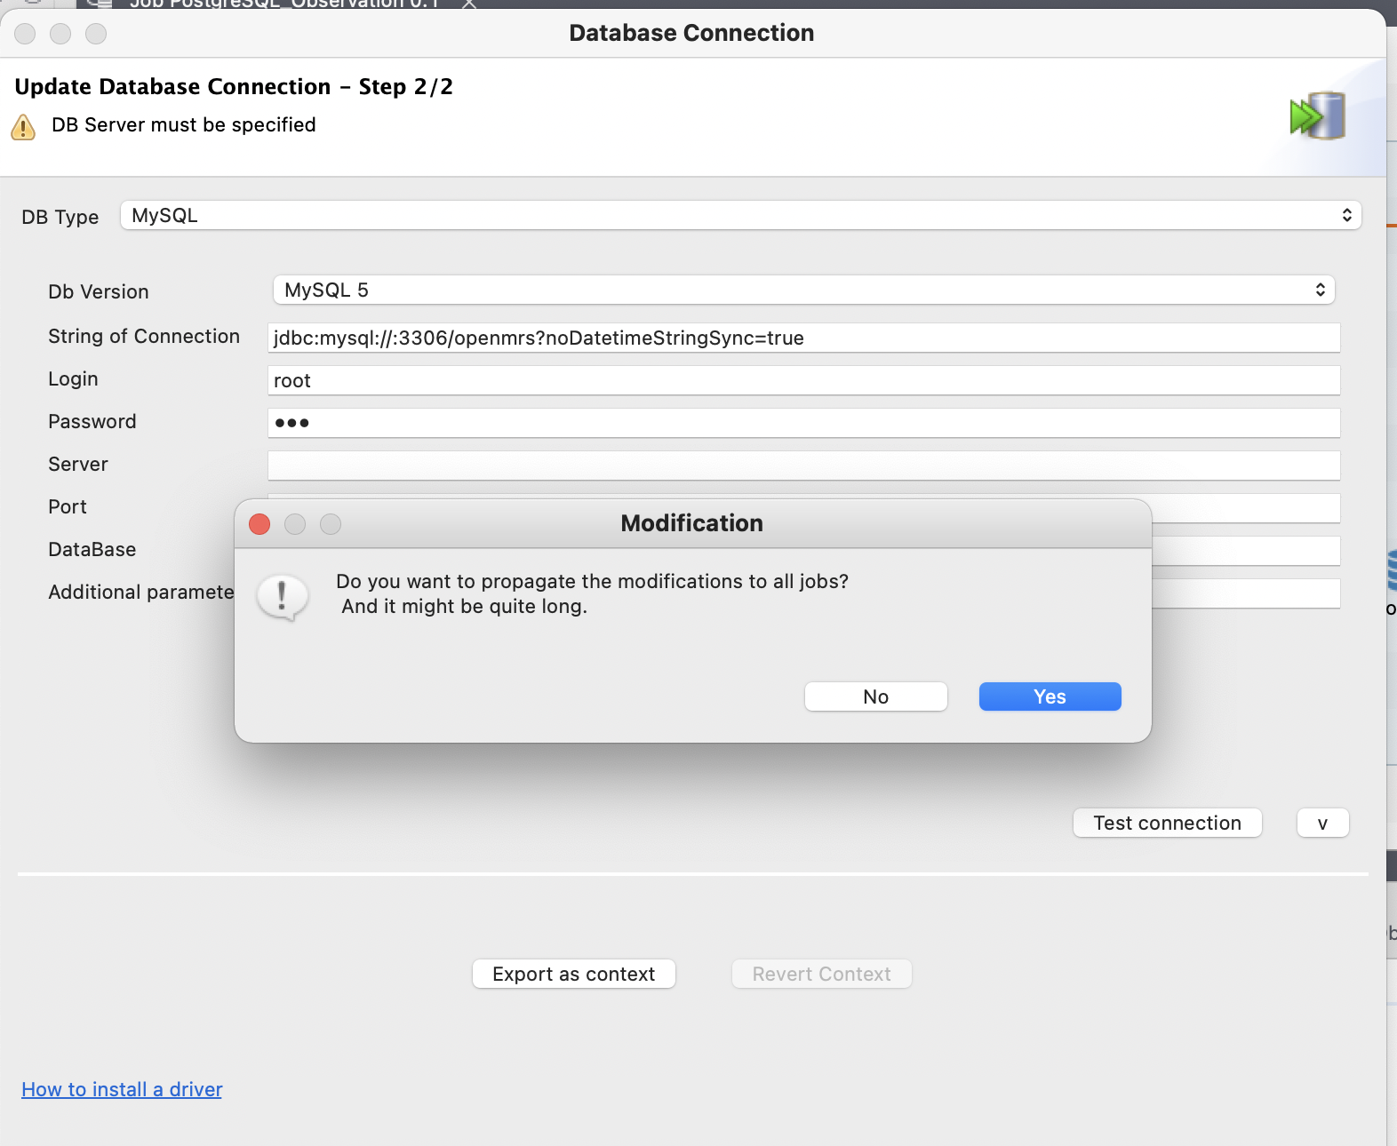

Select Yes to propagate modification.

Edit the properties for *postgresql_db 0.1*, as well.

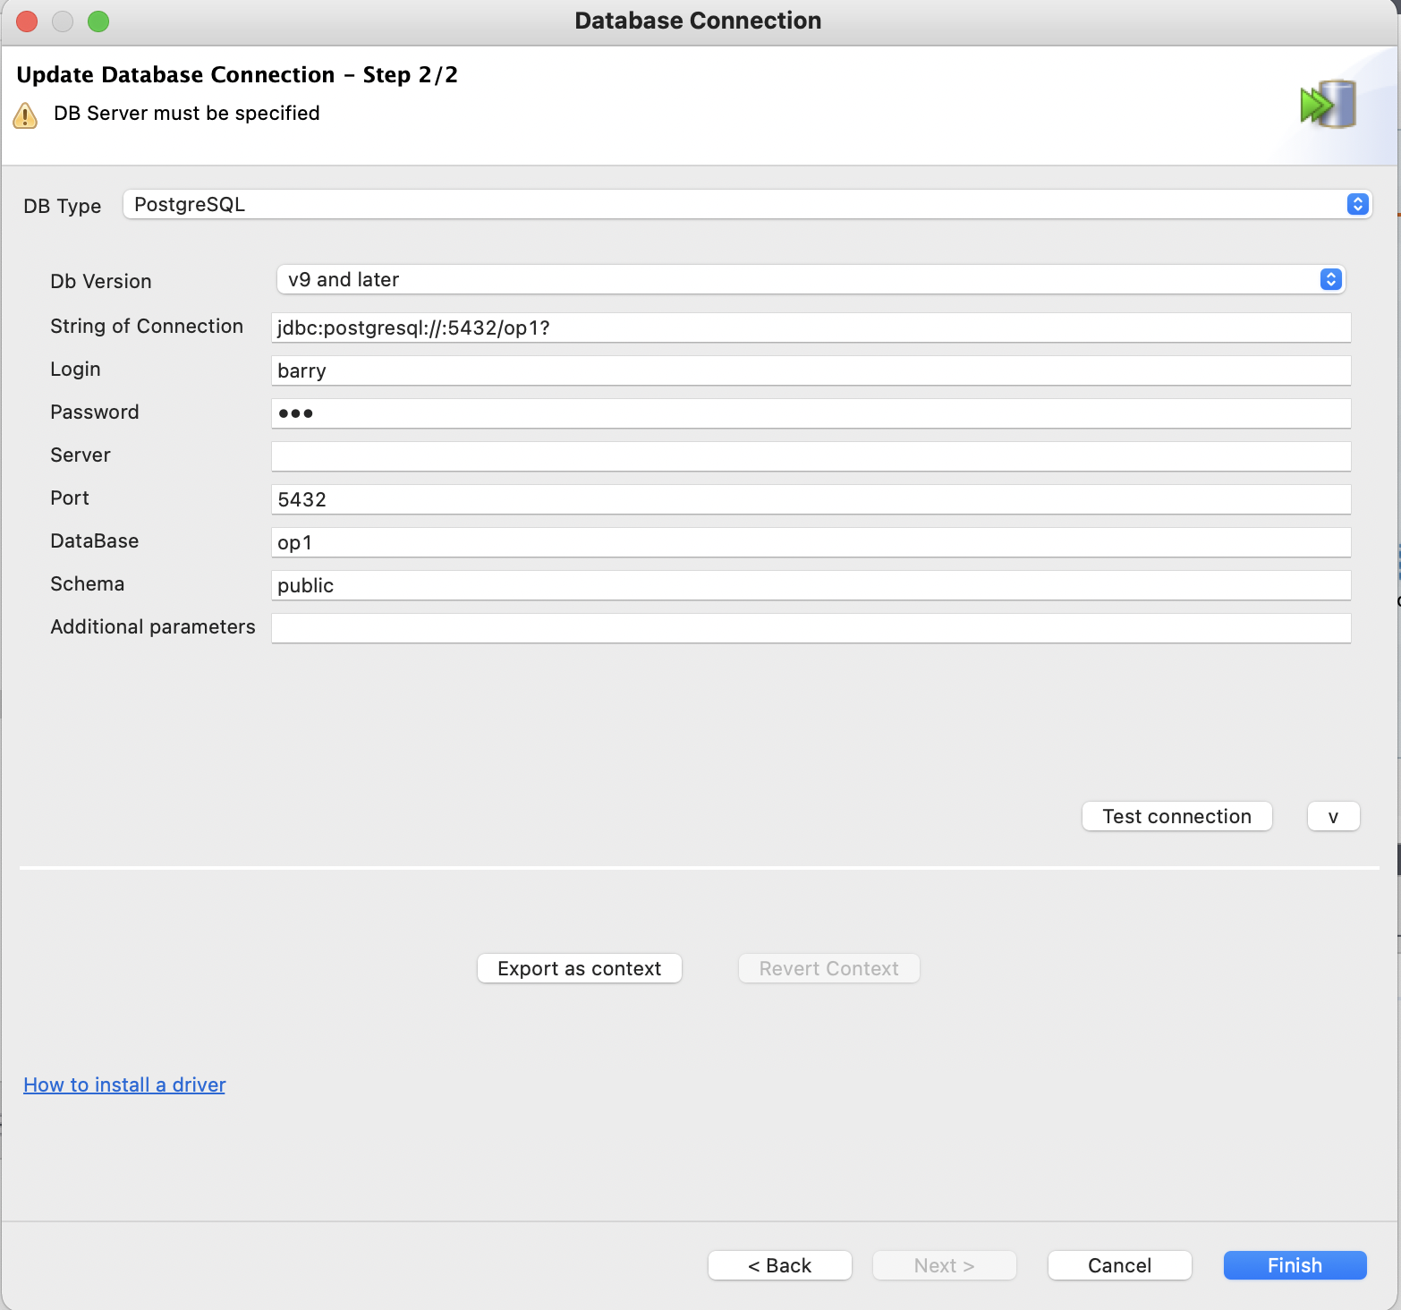

Next, fix the connections in the job:

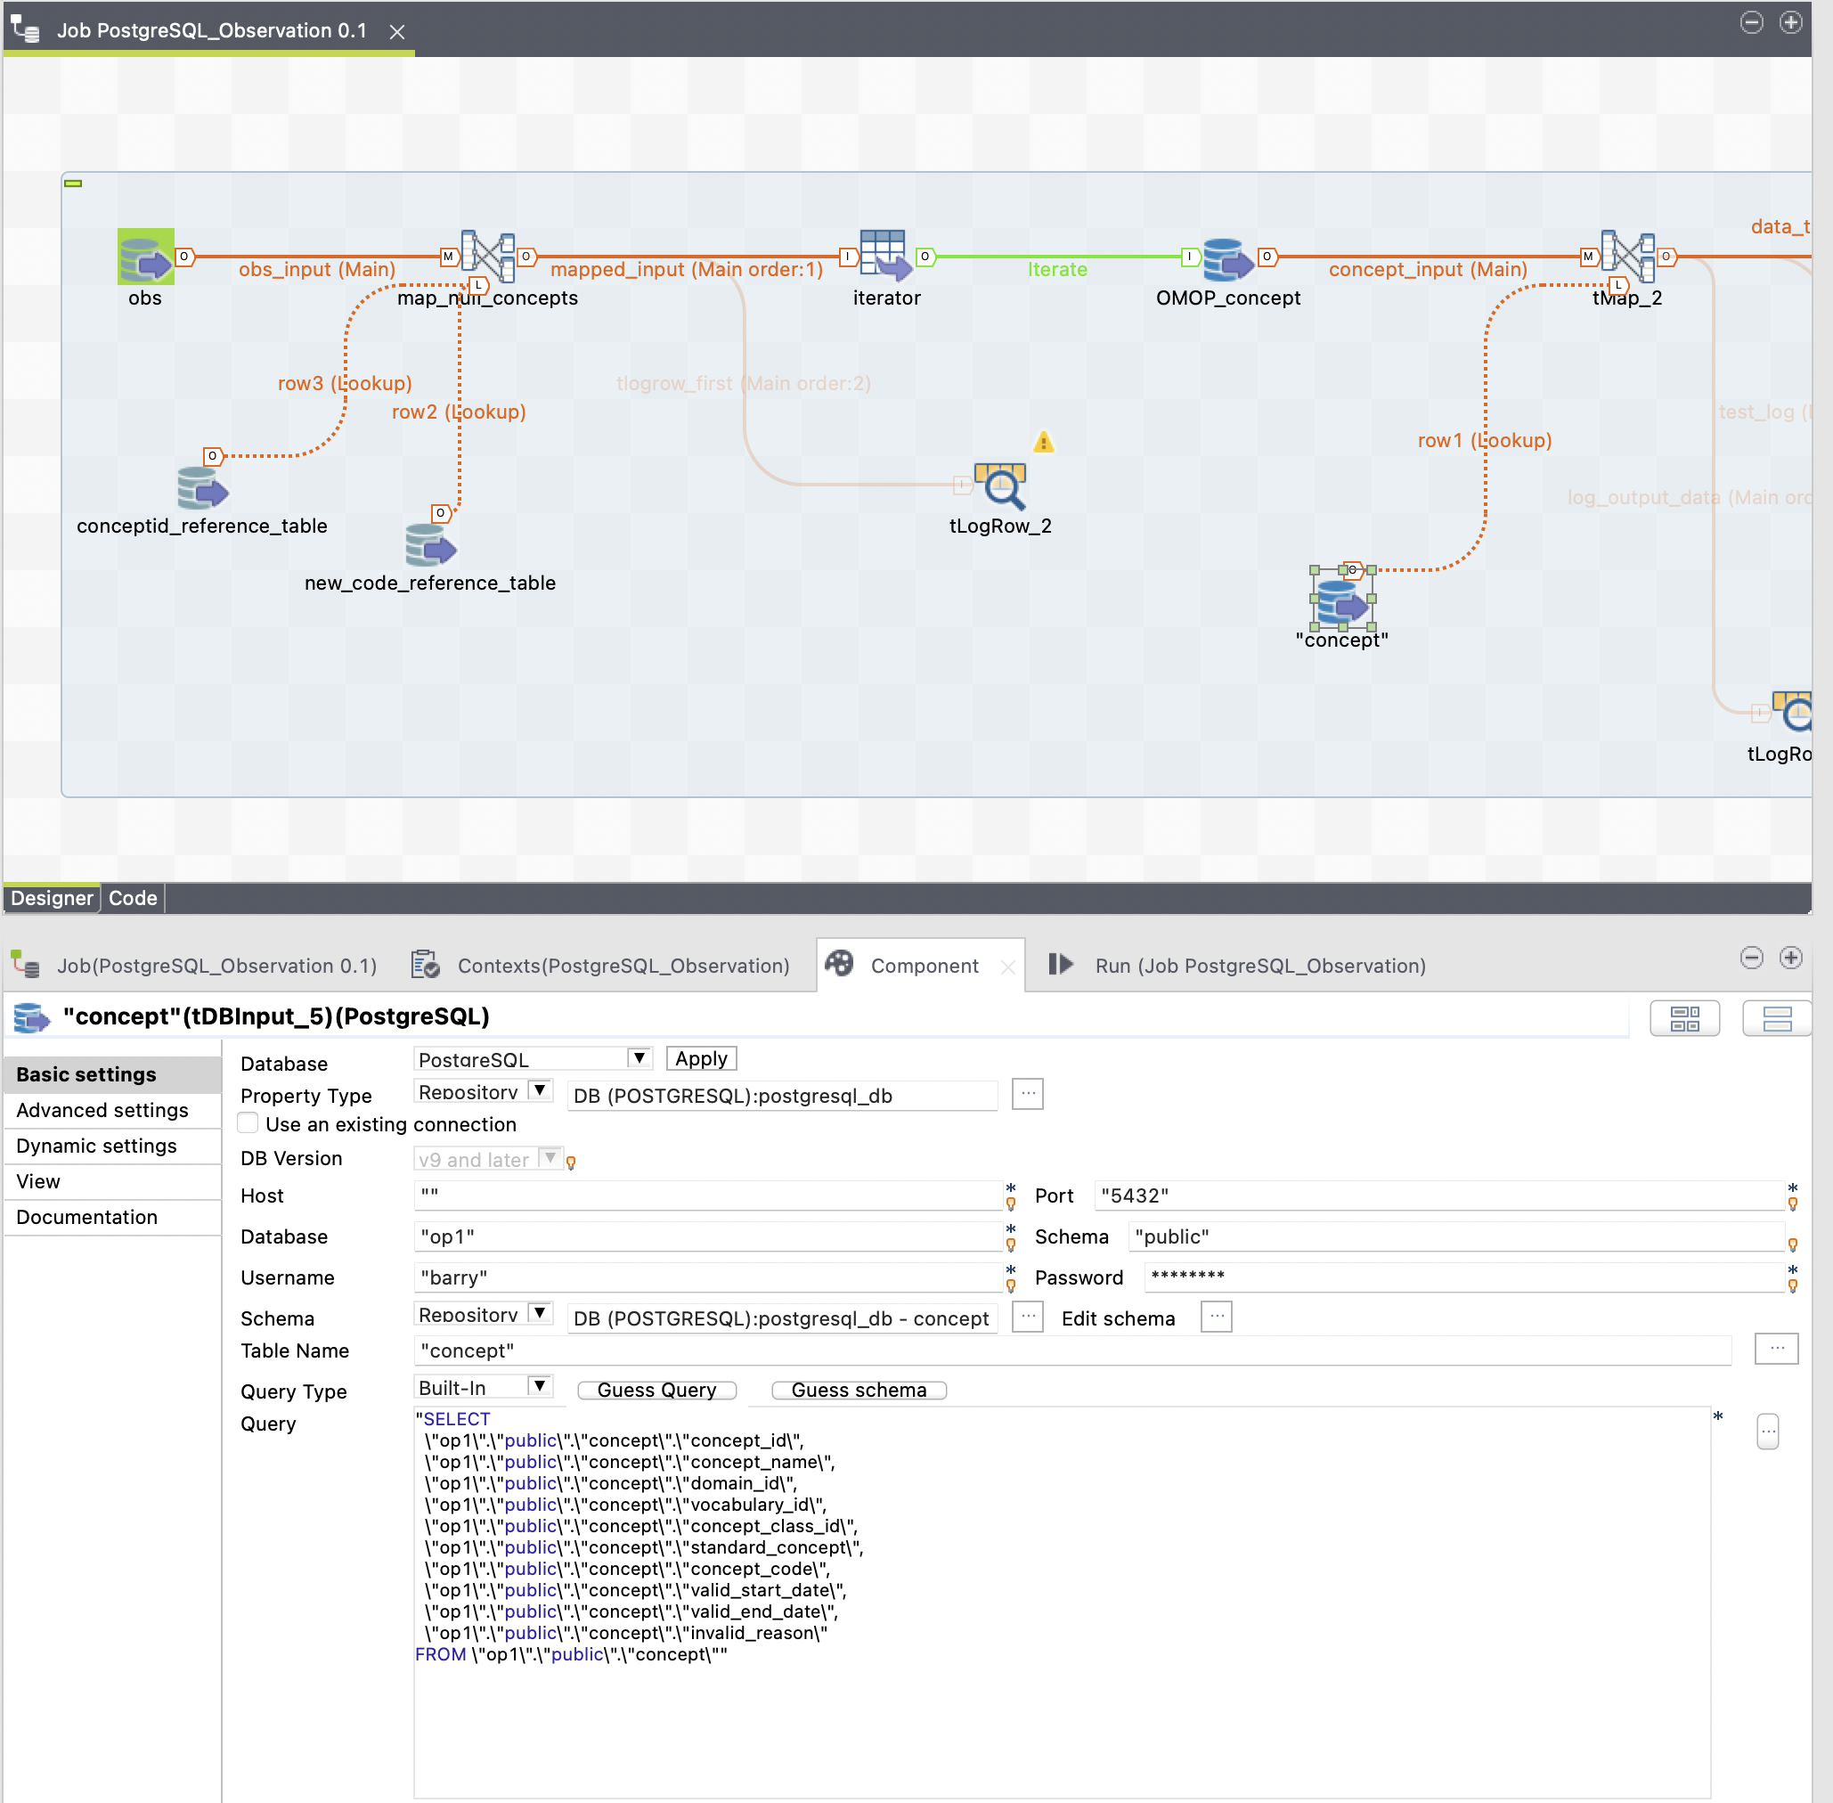

Note, the adjustment to the schema name above.

After updating all of the connection properties the jobs can be run. Recall, the first job to run is *PostgreSQL_Location 0.1*

Jobs are run by:

1. Select the job by double clicking on it in the left-hand panel

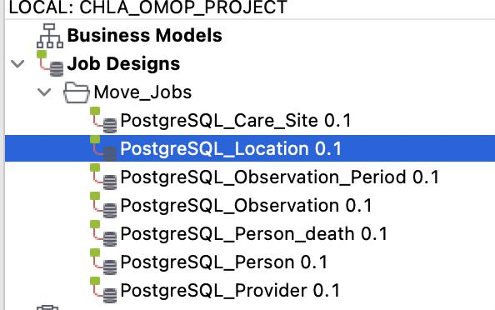

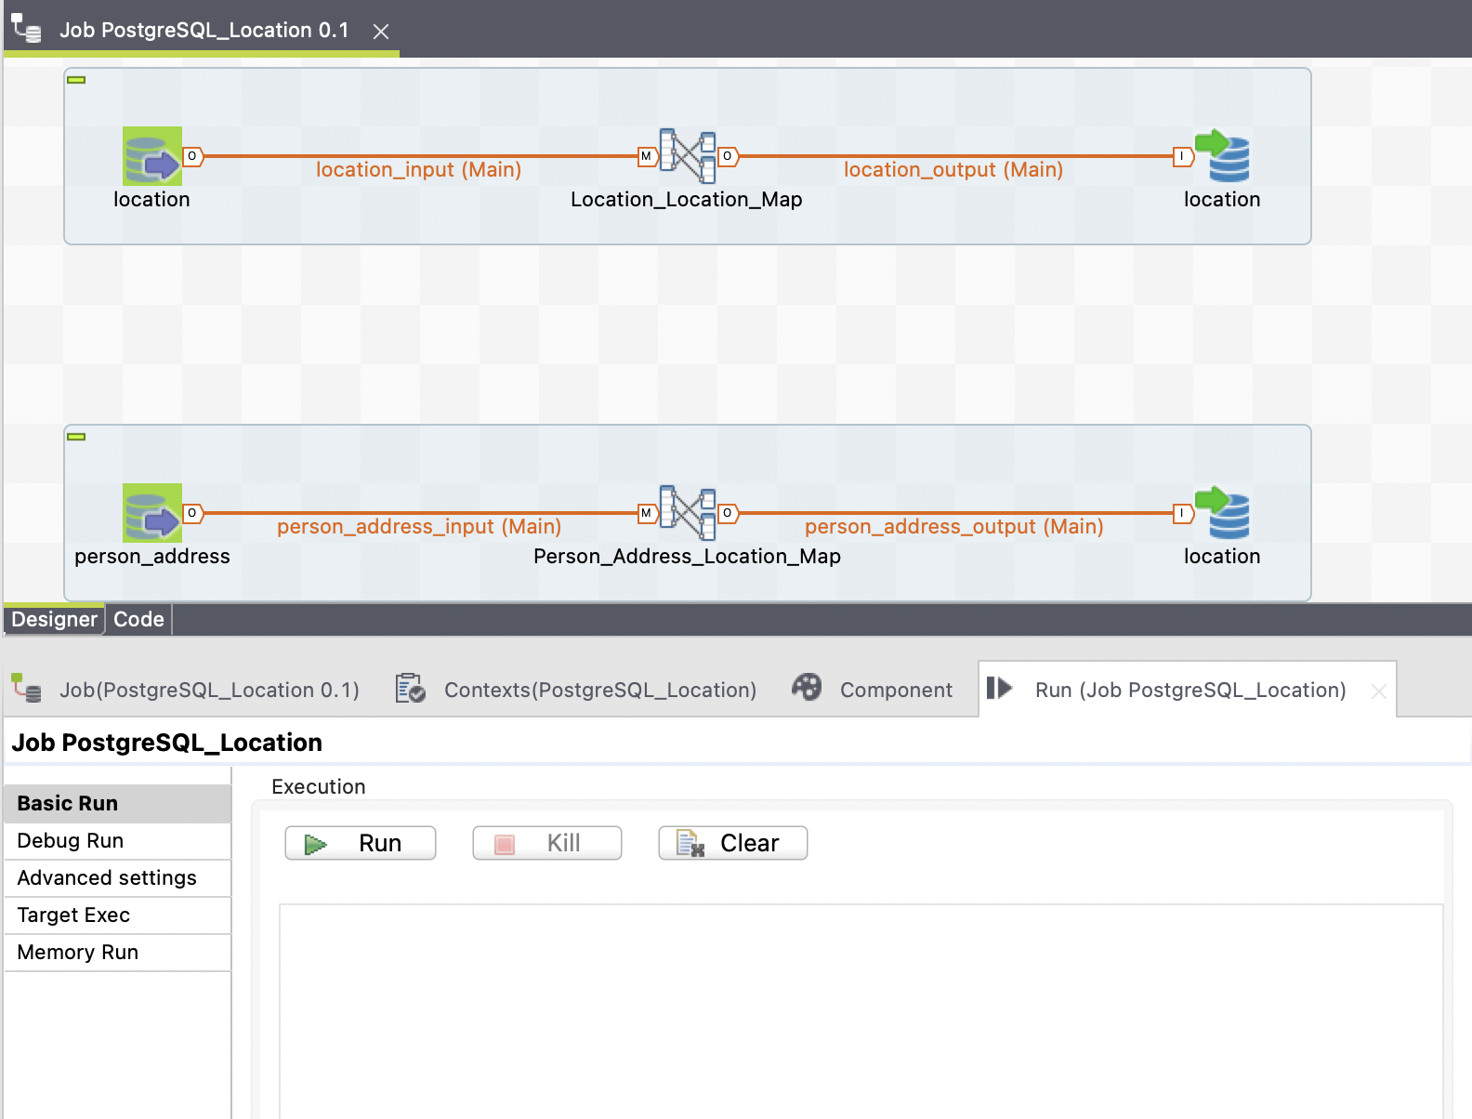

Click on the *Run* button. Upon completion of the run you will see the following:

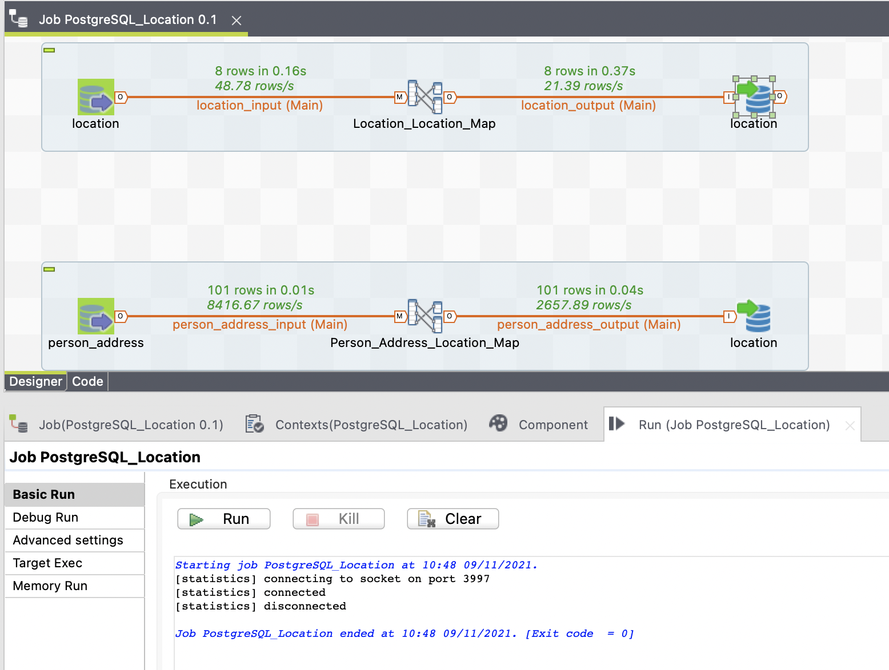

Note the *Exit code = 0* in the *Run* panel and the rows moved in the upper panel.

Notes:

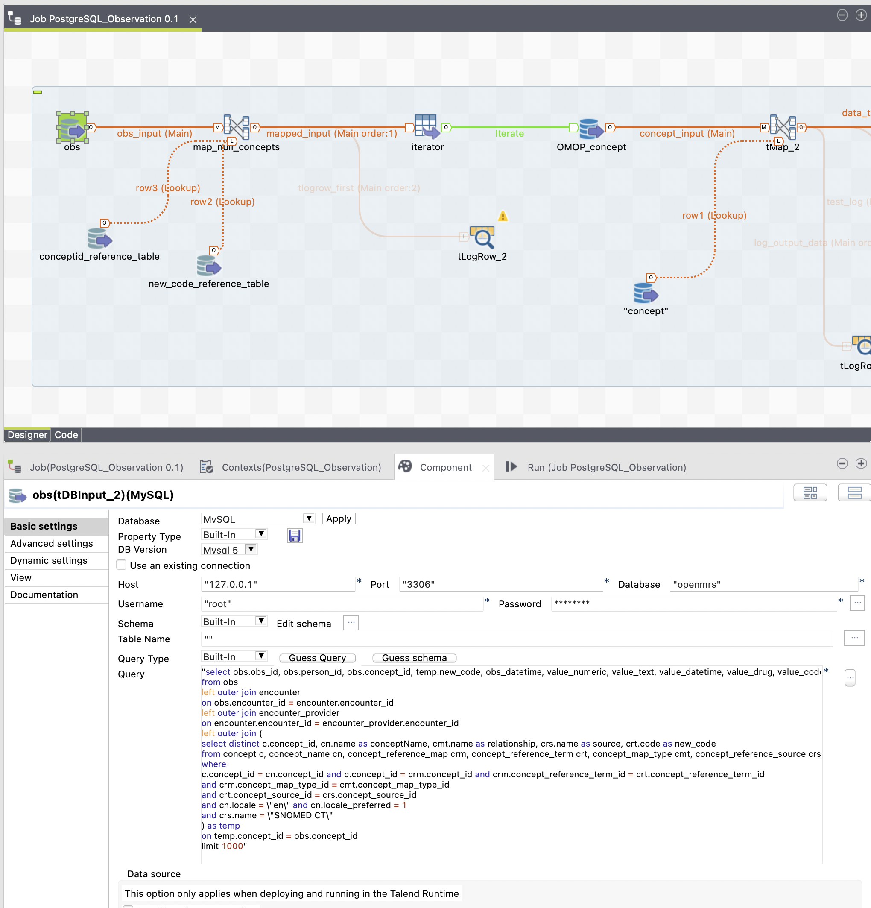

The query in the source obs table (move job PostgreSQL_Observation 0.1) sets a limit at 1000 obs.

Once everything looks good then we want to remove the limit on the number of observations being moved over to PostgreSQL.

Finally, if an OpenMRS concept does not have an exact match in Snomed then we store “0” in the obs table for obs_concept_id.

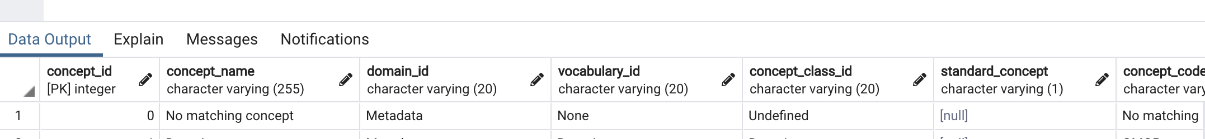

The intent of this tutorial is to demonstrate how to set up and run the Talend ETL tool to run the jobs we created. We suggest you check the available Talend tutorials to expand on our work, e.g., when creating jobs corresponding to other OpenMRS tables.